PIF
Kyrylo Rudchuk
Table of Contents
Raspberry Pi 5
Install Raspberry Pi OS (64-bit) 5
Connecting to the Raspberry Pi 6
I²C interface 7
Static IP and Display Configuration 8
Supplied files 9
Docker 10
Database 11
Introduction 11
CDM 12
Relationships (CDM level) 12
LDM 13
Relationships (LDM level) 13
SQL 14
Users 14
FriendList 14
Stations 15
Measurements 15
Collections 16
CollectionMeasurement 16
CollectionAccess 17
PVC mount 17
Introduction 17
Preparation 18
Machining Procedures 19
Assembly 20
Printed circuit 21
List of materials 21
Introduction 22
Preparation 22
Soldering 23
Assembling 24
Conclusion 25
Power supply 25
Introduction 25
Cutting the Cable 27
Removing the Outer Insulation 27
Removing the Inner Insulation Layer 28
Preparing the Wires 28
Soldering and Insulation 29
Reconnecting the Shielding 29
Conclusion 29
Website 29
Purpose of the site 29
User-facing pages (appearance, purpose, how to use) 30
Login 30
Registration 30
Account 31
AccountEdit 31
Stations 32
StationEdit 32
Measurements 33
MyCollections 34
Collection 35
EditCollection 35
Friends 36
Shared 36
Logout 37
Sensor #1 37
List of materials 38
Introduction 39
ADS1115 Installation 39
MQ135 Sensor Installation 39
Sensor Testing 40
Conclusion 41
Sensor #2 42
List of materials 42
Introduction 43
Sensors Installation 43
Sensors Testing 44
Conclusion 46
Web Database Server 46
Introduction 46
Commands and Configuration 47
System Update 47
Docker Installation 47
Verify Installation 47
Project Structure Creation 48
Docker Compose Configuration 48
Webserver Docker file 49
File Permissions 49
Start Docker Containers 49
Secure MariaDB Installation 50
Database Configuration 51
Verification 52
Website and Database Test 52
phpMyAdmin Test 52
PHP Test 53
Making sure all packages up to date 54
Conclusion 54
Assembly 55
List of materials 55
Introduction 55
Preparing the Opening for the Power Button 55
Assembling the Wooden Box 56
Mounting the Sensors 57
Connecting the Power Button 57
Conclusion 58
Data Transfer 59
Introduction 59
PHP Script Creation 59
Database Preparation 59
Testing Data Transfer 60
Raspberry Pi Configuration 61
Verification 62
Manual Data Entry Form 62
Conclusion 63
Code 63
Lighting 66
List of materials 66
Introduction 66
Preparing the Opening 66
Preparing the LED Strip and Wires 67
Connecting Components 67
Insulation and Mounting 68
Conclusion 68
Backup Server 69
Introduction 69
Web/DB Server Configuration 69
Allow External Access to MariaDB 69
Create Backup User 70
Backup Server Setup 71
System configuration 71
Backup Directory 71
Backup Script 72
Cron Automation 73
FTP 73
Conclusion 75
Code 75

Raspberry Pi

Install Raspberry Pi OS (64-bit)
- Download the Raspberry Pi Imager from the official website: https://www.raspberrypi.com/software/.
- Insert a microSD card into your computer.
- In Raspberry Pi Imager:
Select your Raspberry Pi Device
  - Select Raspberry Pi OS (64-bit).
  - Select your microSD card.
  - Click Next.
  - Configure Raspberry Pi OS
- After flashing, insert the microSD card into your Raspberry Pi and power it on.
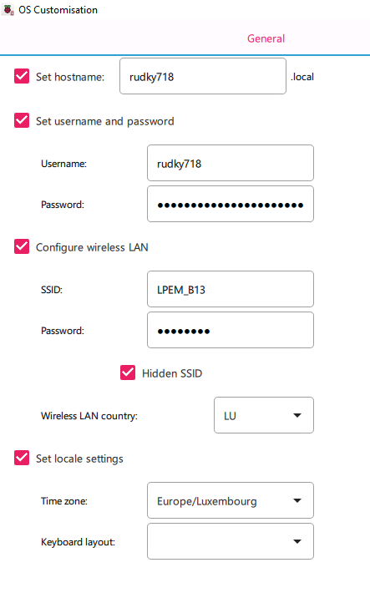
2 OS Customisation

Connecting to the Raspberry Pi
There are two connection methods that I use:
- Via PowerShell (SSH) using the hostname configured during the OS setup.
- Via RealVNC for graphical interface access, also using the configured hostname.
For terminal operations, PowerShell will be used. For visual interface operations, RealVNC will be used.
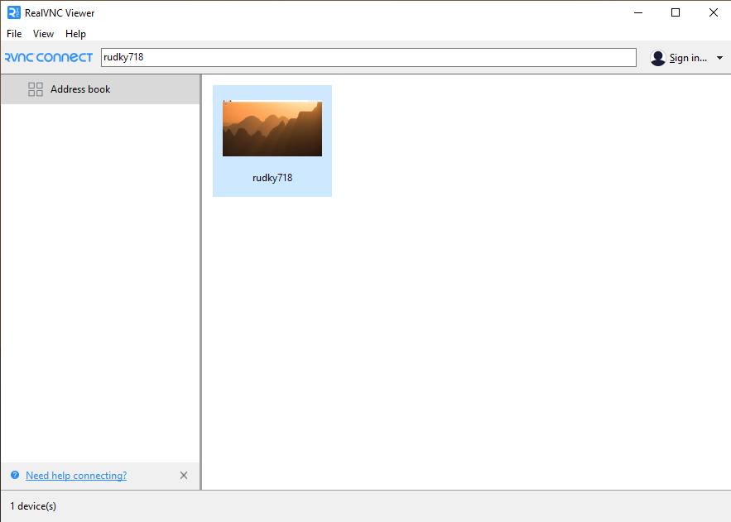
3 RealVNC

I²C interface
- Open a terminal session via PowerShell and launch the Raspberry Pi configuration tool:
sudo raspi-config
- Enable the I²C interface in interface options (required for future operations).
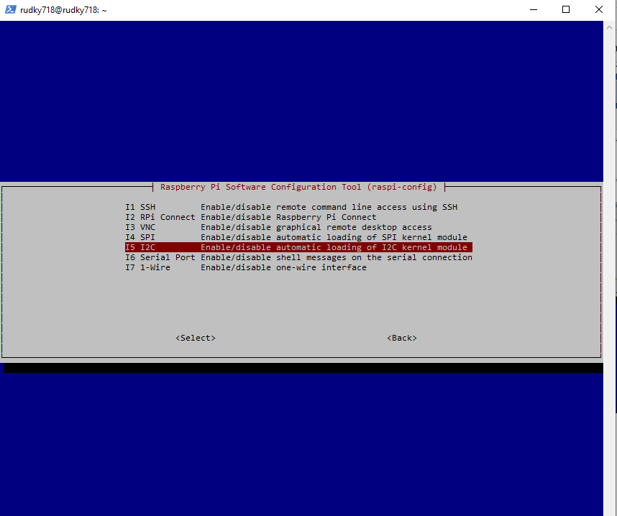
4 I2C raspi-config

Static IP and Display Configuration
- Access the Raspberry Pi via RealVNC for graphical configuration.
- Configure a static IP address:
  - Navigate to Network → Advanced Options → Edit Connections→ IPv4.
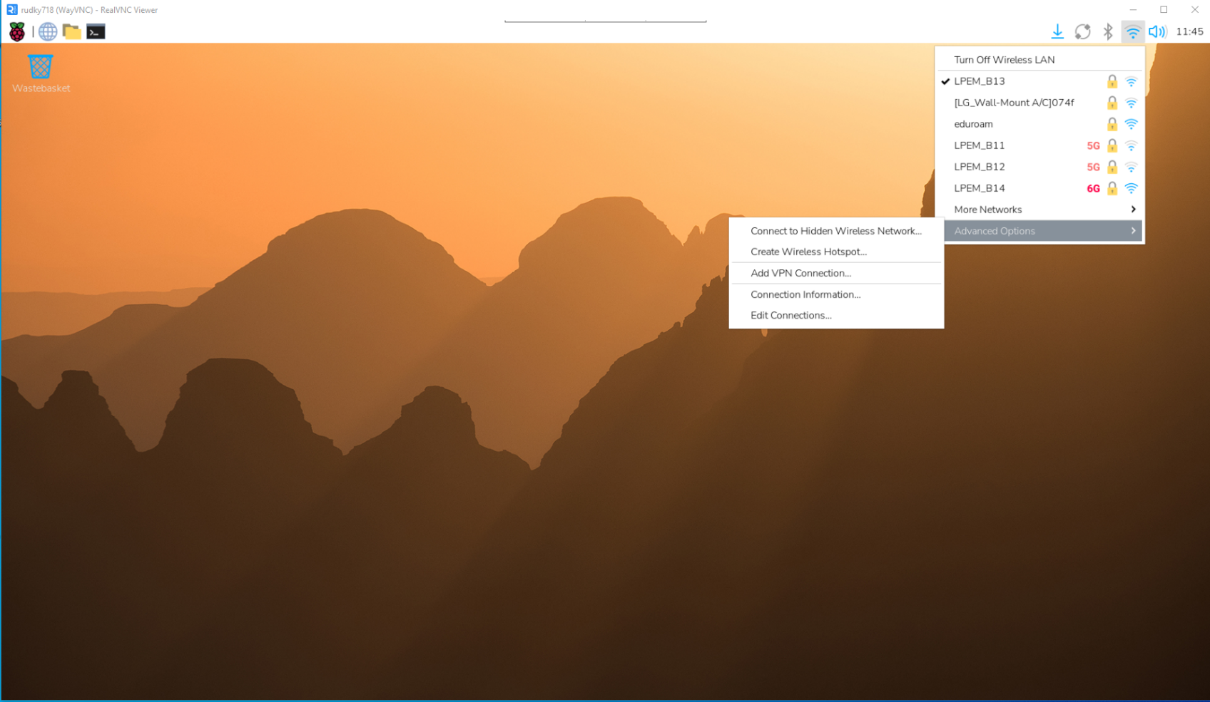
5 Network Advanced Options
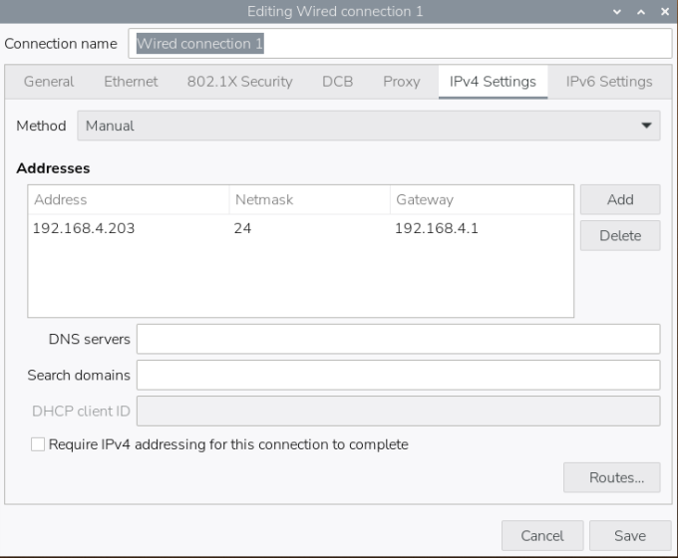
6 Static IP
- Configure the screen orientation in control centre as required.
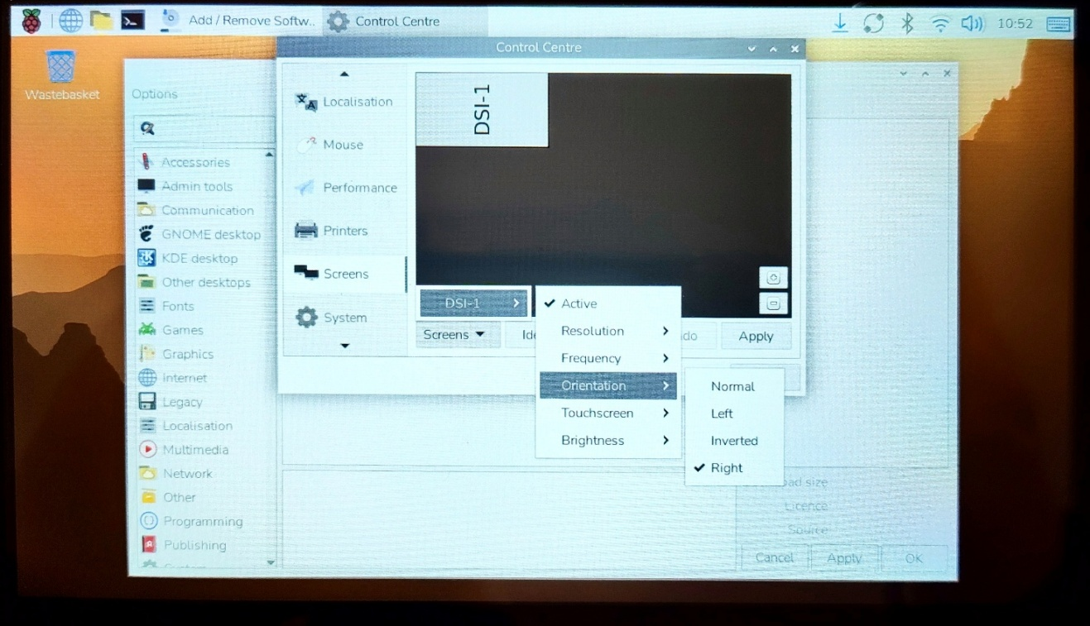
7 Screen orientation

Supplied files
- Create the necessary directories for project files:
sudo mkdir -p /opt/station/www
sudo mkdir -p /opt/station
sudo chmod -R 755 /opt/station
- Transfer the supplied files from a USB stick to the Raspberry Pi:
  - Website files → /opt/station/www.
  - Firmware files, configuration file, and sensor testing scripts → /opt/station
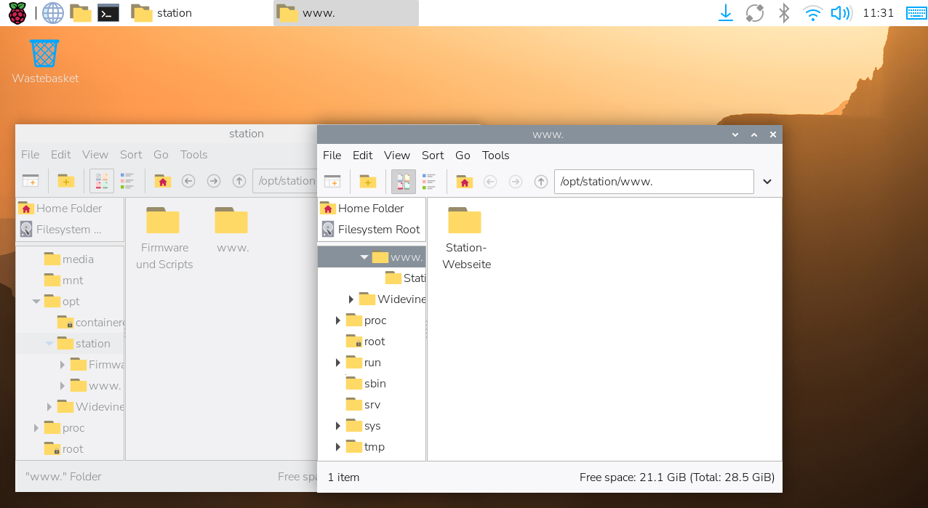
8 Folders

- Configuration File Adjustment
Open the configuration file located among the transferred files
/opt/station/config.toml
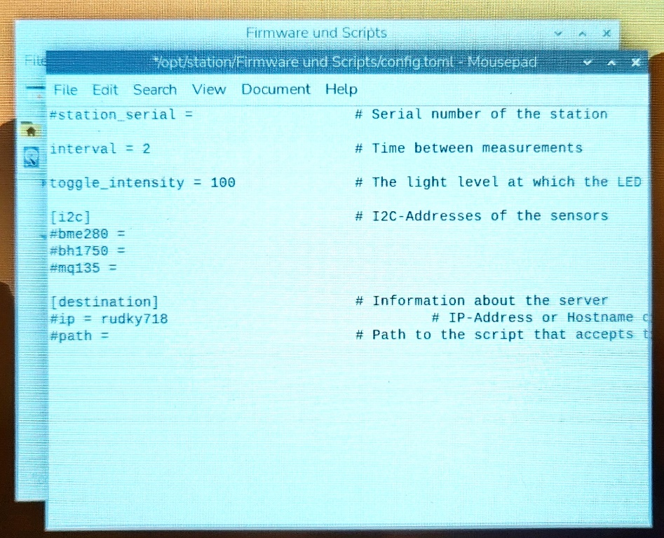
9 config.toml

Docker
- Download and install Docker using the official script:
curl -fsSL https://get.docker.com -o get-docker.sh
sudo sh get-docker.sh
- Launch a Docker container:
docker run -d --name php --restart unless-stopped -p 8080:80 -v /tmp/station:/tmp/station -v /opt/station/www:/var/www/html php:8.4-apache
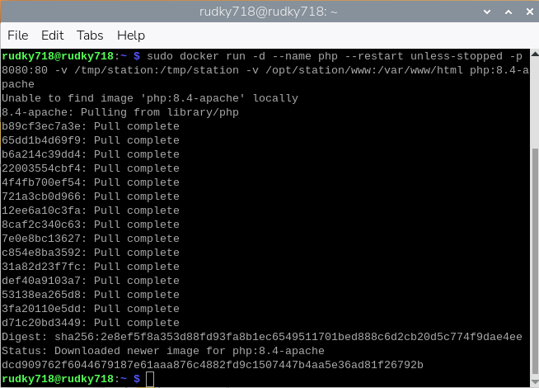
10 Docker container launch
- Configure Docker to run without sudo:
sudo groupadd docker
sudo usermod -aG docker $USER
- Verify that the container is running and that Docker can be used without sudo:
docker ps
11 docker ps

Database

Introduction
This document describes the database design and implementation for the measurement-station project. The system stores environmental measurements (temperature, humidity, air pressure, light intensity, air quality) produced by devices called stations. Users (customers and administrators) sign up, register stations, view measurement data, build collections of measurements and share collections with friends (view-only). The goal of the database is to reliably store and expose data for the website, enforce essential integrity, and be easy to query for UI features such as listing stations, filtering measurements by time range and sharing collections.

CDM
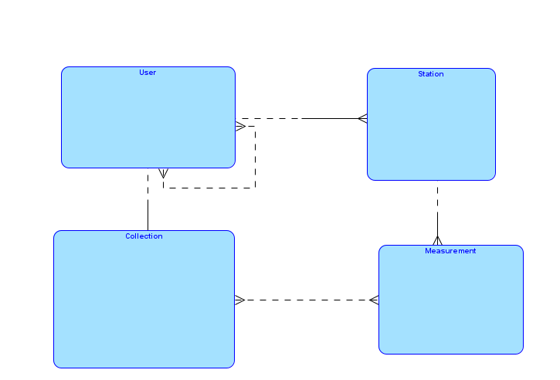
1 CDM

Relationships (CDM level)
User 1 : N Station
Station 1 : N Measurement
User 1 : N Collection
Collection M : N Measurement
User M : N User (self many-to-many)
Collection M : N User

LDM

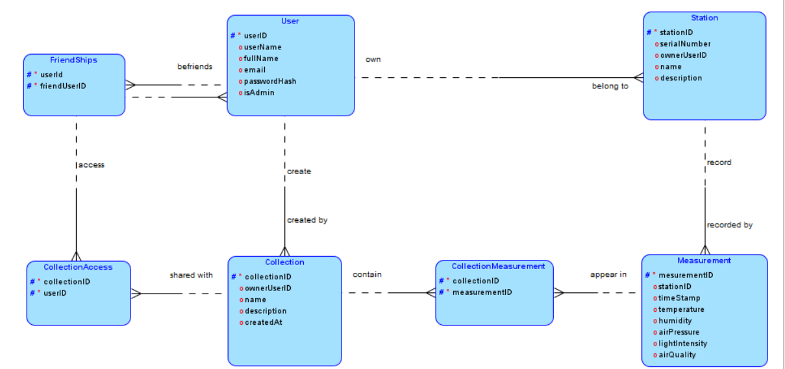
2 LDM

Relationships (LDM level)
User can own one or many stations.
Station must belong to one and only one user.
Station can produce one or many measurements.
Measurement must be recorded by one and only one station.
User can create one or many collections.
Collection must be created by one and only one user.
Collection can contain many measurements.
Measurement can appear in many collections.
User can befriend many users.
Friendship always links two and only two users.
Collection can be shared with many users.
User can access many collections shared with him.

SQL

Users
userID INT AUTO_INCREMENT PRIMARY KEY,
username VARCHAR(50) NOT NULL UNIQUE,
fullName VARCHAR(100) NOT NULL,
email VARCHAR(100) NOT NULL UNIQUE,
passwordHash VARCHAR(255) NOT NULL,
isAdmin BOOLEAN NOT NULL DEFAULT FALSE

- Purpose: Central entity of the system. Stores all registered accounts, including both normal users and administrators. Users are the foundation for ownership of stations, creation of collections, friendships, and access rights. Without users, no other entity can exist in the system.
- Primary Key: userID
- Foreign Keys: None directly, but referenced by other tables.
- Usage in other tables:
  - FriendList (friendship relations)
  - Stations (station ownership)
  - Collections (collection creator)
  - CollectionAccess (shared access to collections)

FriendList
userID1 INT NOT NULL,
userID2 INT NOT NULL,
PRIMARY KEY(userID1, userID2),
FOREIGN KEY(userID1) REFERENCES Users(userID) ON DELETE CASCADE,
FOREIGN KEY(userID2) REFERENCES Users(userID) ON DELETE CASCADE,
CHECK (userID1 <> userID2)

- Purpose: Implements friendships between users. This table enables social interaction and sharing features by linking two distinct users together. It is essential for enabling collection sharing, since only friends can be granted access.
- Primary Key: (userID1, userID2) (composite)
- Foreign Keys:
  - userID1 → Users.userID
  - userID2 → Users.userID
- Usage in other tables:
  - Indirectly supports CollectionAccess by defining who can be shared with.

Stations
stationID INT AUTO_INCREMENT PRIMARY KEY,
serialNumber VARCHAR(20) NOT NULL UNIQUE,
name VARCHAR(100) NOT NULL,
description TEXT,
ownerUserID INT NOT NULL,
FOREIGN KEY(ownerUserID) REFERENCES Users(userID) ON DELETE CASCADE

- Purpose: Represents physical measurement devices owned by users. Each station has a unique company-assigned serial number and can be named and described by the customer. Stations are the source of all measurement data in the system.
- Primary Key: stationID
- Foreign Keys:
  - ownerUserID → Users.userID
- Usage in other tables:
  - Measurements (records sensor data linked to stations)

Measurements
measurementID INT AUTO_INCREMENT PRIMARY KEY,
stationID INT NOT NULL,
timestamp DATETIME NOT NULL,
temperature FLOAT NOT NULL,
humidity FLOAT NOT NULL,
airPressure FLOAT NOT NULL,
lightIntensity FLOAT NOT NULL,
airQuality FLOAT NOT NULL,
FOREIGN KEY(stationID) REFERENCES Stations(stationID) ON DELETE CASCADE

- Purpose: Stores environmental readings collected from stations. Each measurement is tied to one station and contains timestamped values such as temperature, humidity, air pressure, light intensity, and air quality. This table is the core data source for analysis and visualization.
- Primary Key: measurementID
- Foreign Keys:
  - stationID → Stations.stationID
- Usage in other tables:
  - CollectionMeasurement (groups measurements into collections)

Collections
collectionID INT AUTO_INCREMENT PRIMARY KEY,
creatorUserID INT NOT NULL,
name VARCHAR(100) NOT NULL,
description TEXT,
FOREIGN KEY(creatorUserID) REFERENCES Users(userID) ON DELETE CASCADE

- Purpose: Logical grouping of measurements created by users. Collections allow customers to organize data (e.g., by time period, station, or analysis purpose). They can be empty or filled with measurements. Collections are also the unit of sharing between friends.
- Primary Key: collectionID
- Foreign Keys:
  - creatorUserID → Users.userID
- Usage in other tables:
  - CollectionMeasurement (links collections to measurements)
  - CollectionAccess (grants access to other users)

CollectionMeasurement
collectionID INT NOT NULL,
measurementID INT NOT NULL,
PRIMARY KEY(collectionID, measurementID),
FOREIGN KEY(collectionID) REFERENCES Collections(collectionID) ON DELETE CASCADE,
FOREIGN KEY(measurementID) REFERENCES Measurements(measurementID) ON DELETE CASCADE

- Purpose: Junction table that enables many-to-many relationships between collections and measurements. It allows one measurement to be part of multiple collections and one collection to contain multiple measurements.
- Primary Key: (collectionID, measurementID) (composite)
- Foreign Keys:
  - collectionID → Collections.collectionID
  - measurementID → Measurements.measurementID
- Usage in other tables:
  - Acts as a bridge between Collections and Measurements.

CollectionAccess
collectionID INT NOT NULL,
userID INT NOT NULL,
PRIMARY KEY(collectionID, userID),
FOREIGN KEY(collectionID) REFERENCES Collections(collectionID) ON DELETE CASCADE,
FOREIGN KEY(userID) REFERENCES Users(userID) ON DELETE CASCADE

- Purpose: Manages sharing of collections with other users. This table defines which users have read-only access to a given collection. It enables collaboration and data sharing while preserving ownership rights for the creator.
- Primary Key: (collectionID, userID) (composite)
- Foreign Keys:
  - collectionID → Collections.collectionID
  - userID → Users.userID
- Usage in other tables:
  - Provides access control for collections, based on friendships defined in FriendList.

PVC mount

Introduction
This report describes the machining and assembly steps required to prepare the PVC base plate and PVC display mount, followed by the attachment of the Raspberry Pi and touch display. All actions had to be performed carefully and confidently, as no spare parts were available.

Preparation
Before beginning any machining work, each PVC part had to be prepared. All components (PVC base plate and PVC display mount) had to be marked with the personal IAM code using a permanent marker to ensure traceability. Precise reference markings for drilling had to be made using a fine scribing tool (scraper) to achieve accurate guidelines.
Additionally, at each marked drilling point, a small indentation had to be made to allow the drill bit to self-center more easily during drilling and prevent slipping.
These markings and indentations had to be checked against the dimensional documentation. Finally, all positions had to be verified by comparing them with the teacher-approved model to ensure proper alignment and avoid potential errors before machining began.
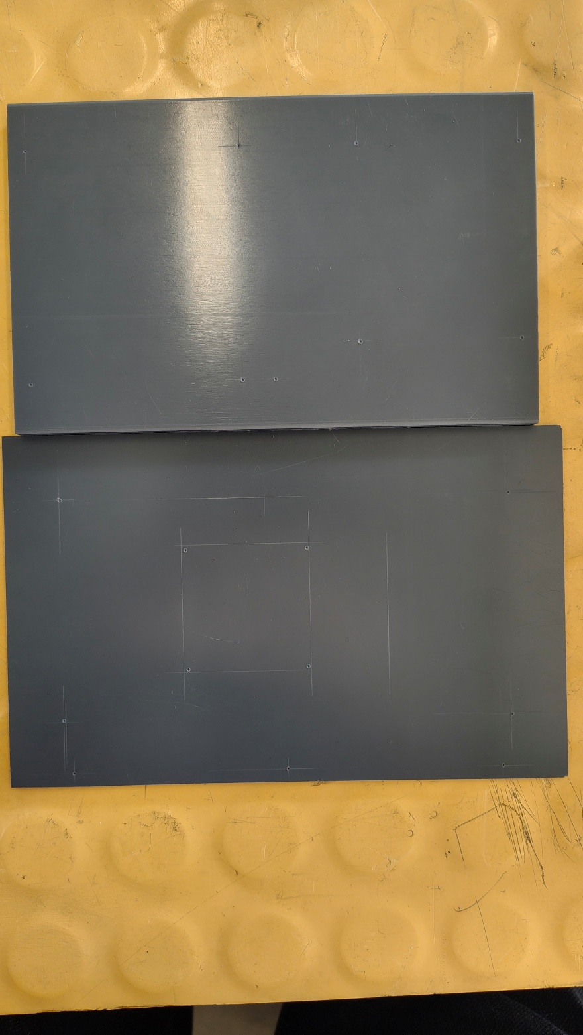
1 Scraped PVC

Machining Procedures
After the marked and indented drill points were verified, drilling had to be carried out using the appropriate drill bit diameters (2.3 mm, 2.5 mm, 3 mm, and 4 mm depending on the function of each hole). After drilling, all holes had to be deburred. The opening for the display cable had to be made by drilling four corner holes, then cutting the interior with a saw, and finally smoothing and finishing the edges using a sanding stick.
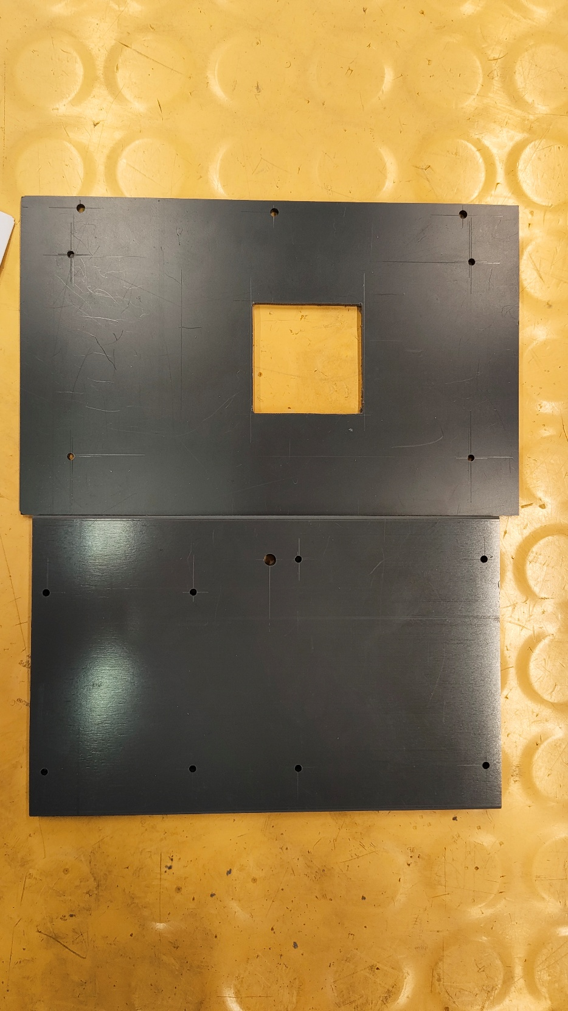
2 Drilled PVC

Assembly
The PVC display mount had to be fixed to the base plate. The cables had to be disconnected from the Raspberry Pi, routed through the machined opening, and reconnected to the display after assembly.
The touch display had to be mounted to the PVC display mount using the supplied 5 mm spacer sleeves. The Raspberry Pi had to be attached to the base plate using 5 mm spacer sleeves.
Once all components were aligned and secured, the assembly was complete.

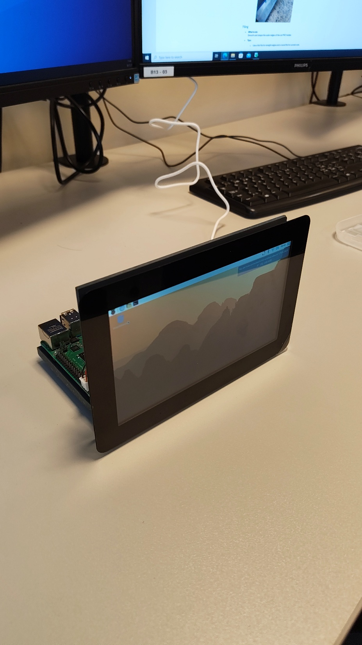
3 Assemble result from the angle
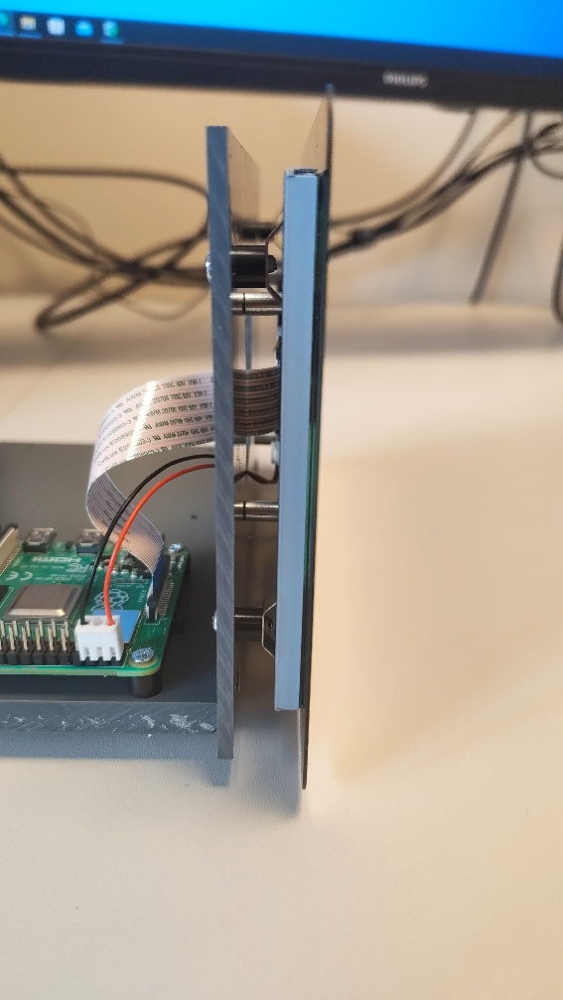
4 Assemble result from the side

Printed circuit

List of materials
Component | Quantity
2-layer printed circuit board 75 x 85 mm | 1
40-pin straight connector strip R WS40G | 1
GPIO ribbon cable for Raspberry Pi Model B+ (40 pins) | 1
Metal resistor 0207 0.6W 10K | 1
Metal resistor 0207 0.6W 56K | 1
BC517 transistor | 1
PCB connection terminal 2-pin RM 5 | 2
PCB terminal block, 2-pin RM 3.5 | 2
1-row angled socket strip 1 x 4 -RM2.54mm h=8mm | 1
1-row angled female connector strip 1 x 7 -RM2.54mm h=8mm | 1
Pin strip, 1 row, straight, 1 x 3 - RM2.54 mm | 1
PCB connector, straight pin header with female connector (set with cable) | 1
M3 x 12 countersunk head | 3
M2.5 x 20 countersunk head | 8
ADS1115 ADC module I2C (Extra) | 1

Introduction
The objective of this task is to assemble a functional Printed Circuit Board (PCB) by soldering electronic components onto it. The PCB provides both mechanical support and electrical connections, allowing integration with other sensors. Proper soldering is essential to avoid short circuits and unreliable connections.

Preparation
Before soldering, the documentation must be reviewed to reduce the risk of faults. Also, use a digital multimeter to check the resistors and verify that their actual resistance values match the required specifications before installing them on the board.
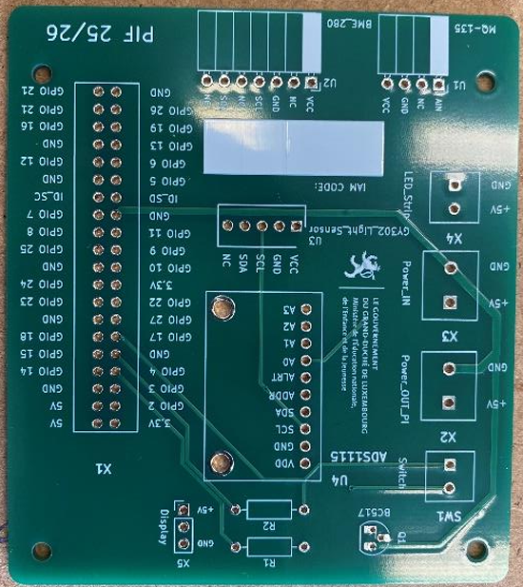
1 PCB

Soldering
Components must be placed in their designated footprints and soldered correctly.
Guidelines:
- Keep the soldering area clean and free of dust.
- Use an appropriate amount of solder.
- Solder joints should be smooth and shiny.
- Avoid overheating the PCB to prevent damage.
- After soldering, electrical connections could be checked with a multimeter.
- Any protruding component leads or pins must be trimmed after soldering.
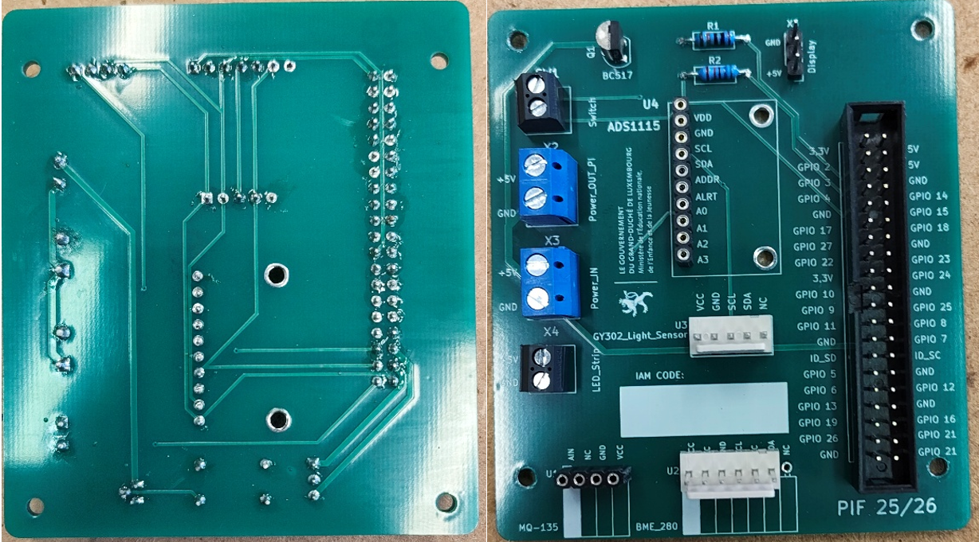
2 Soldered PCB

Assembling
Mounting:
- After soldering, attach the PCB to the plastic (PVC) panel using screws.
- Do not overtighten the screws to avoid damaging the board.
Cable connection:
- Connect the cables according to the reference or documentation provided.
- Handle components with weak pins carefully and avoid applying excessive force.
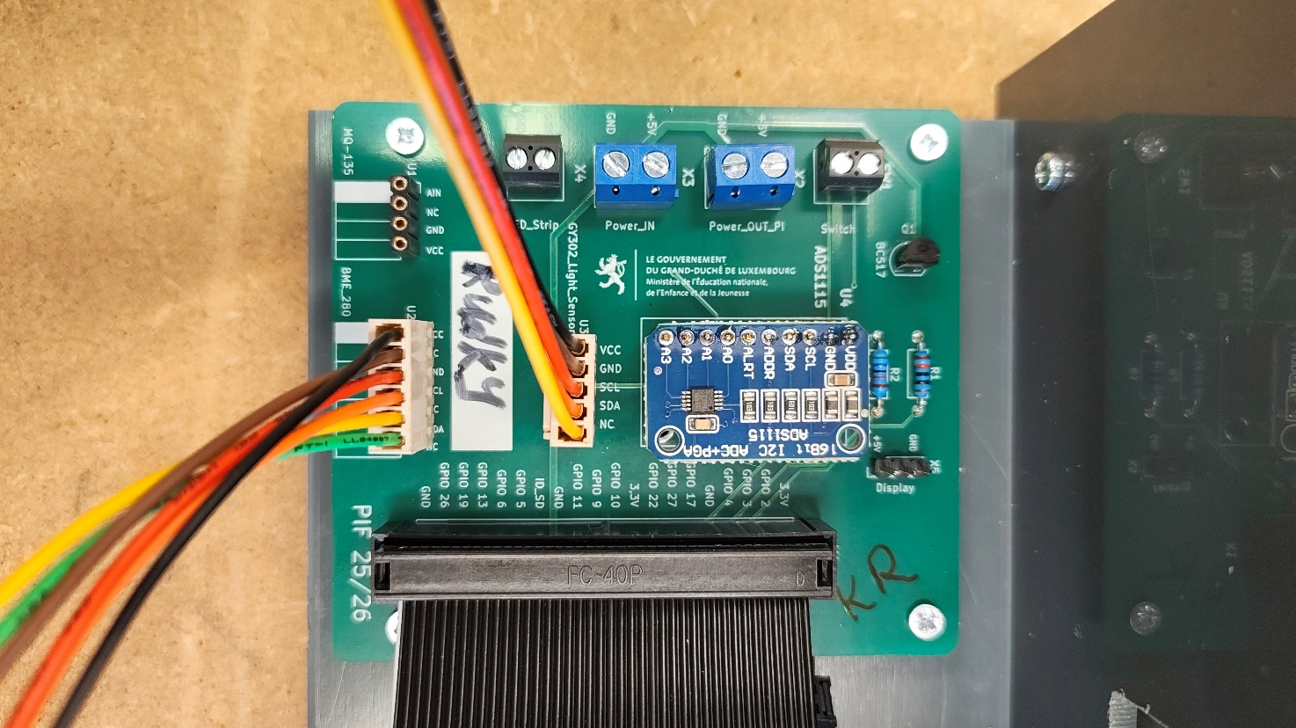
3 Assembled PSB

Conclusion
The PCB has been successfully assembled. All components are securely mounted and properly soldered. The board is ready for further sensor integration and future development stages.
As an addition, an extra module was soldered onto the PCB. This component is intended for future sensor integration.
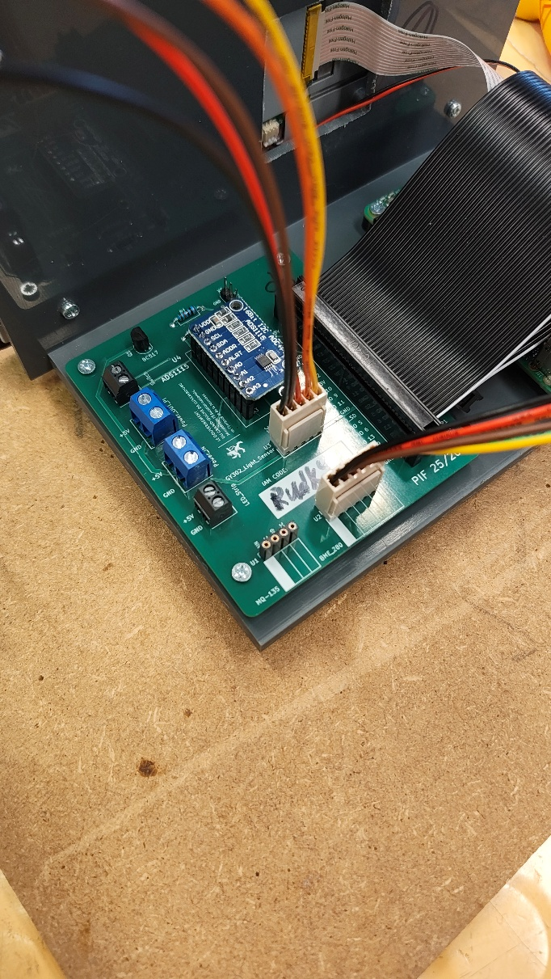
4 Assembled PCB from another angle

Power supply

Introduction
The goal of this work is to learn how to repair a damaged cable using wire stripping and soldering. A multi-layer cable consists of an outer insulation, metallic shielding, an inner protective layer, and four internal wires. By carefully cutting, stripping, and soldering these parts, the cable can be safely restored.
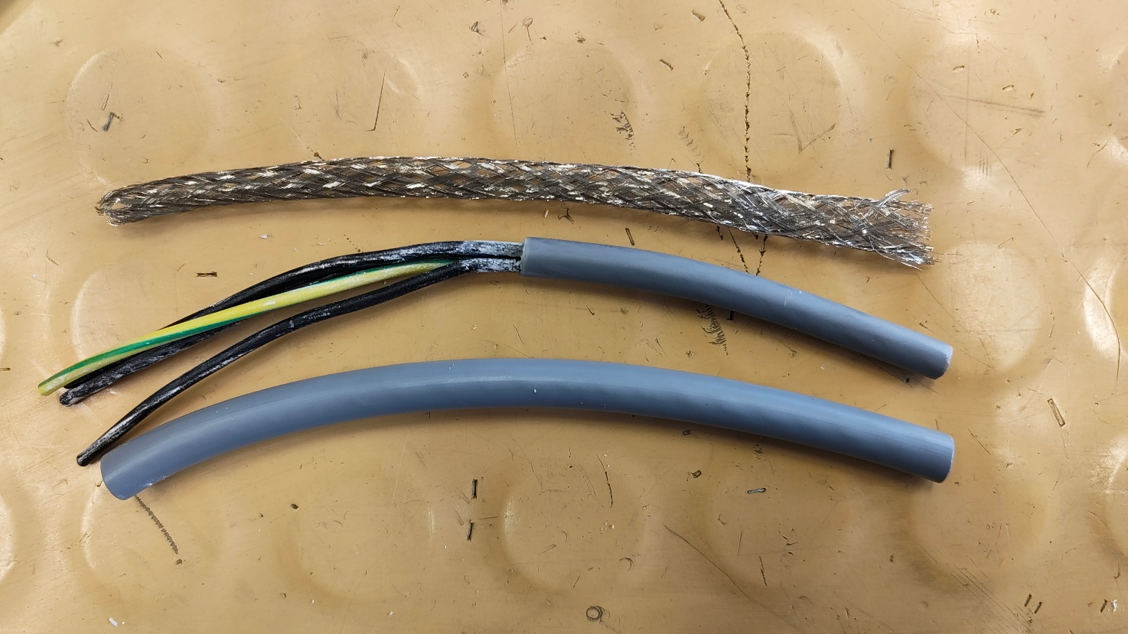

Cutting the Cable
Initially, the cable is undamaged.
The first action is to cut the cable in half using wire cutters. This creates two separate cable ends that will later be reconnected.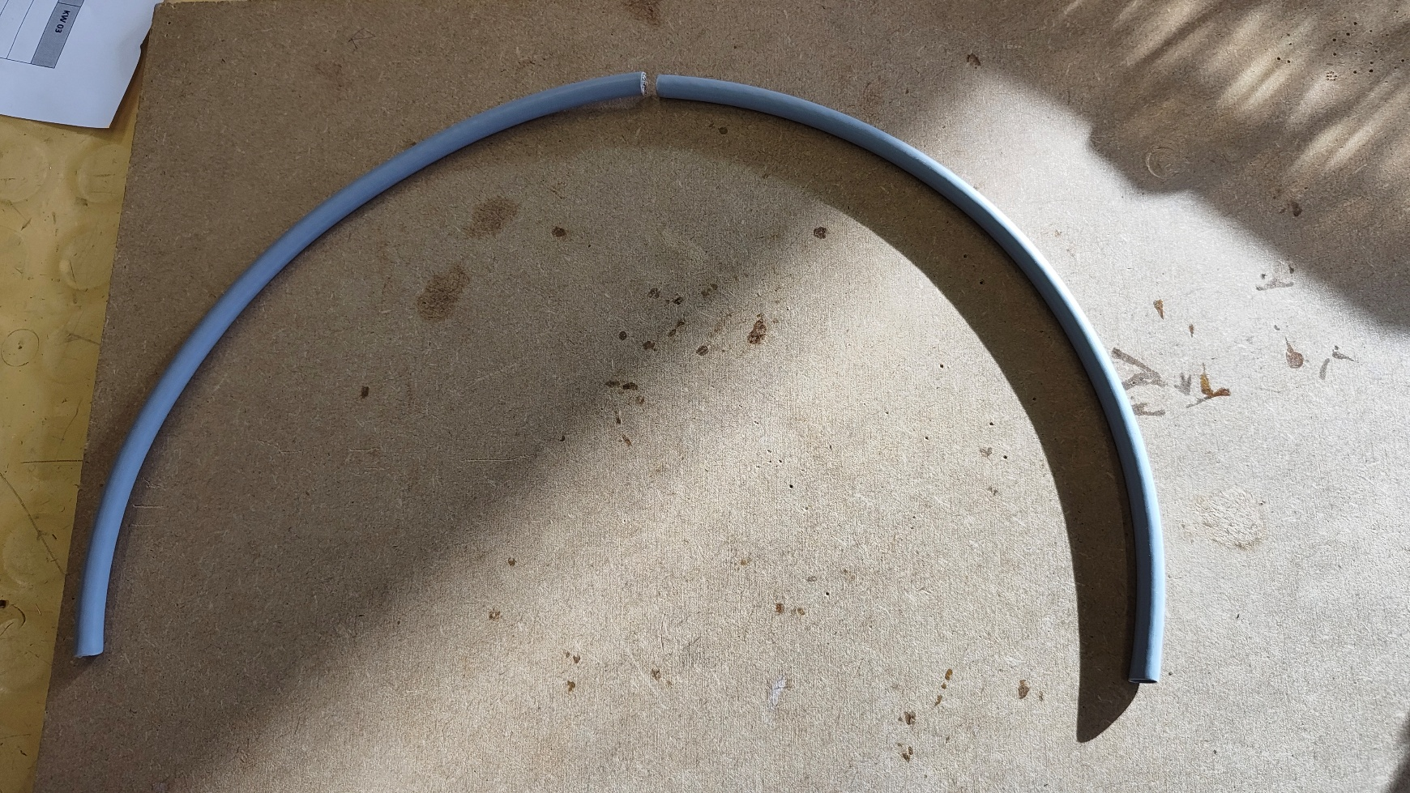

Removing the Outer Insulation
Next, the outer insulation layer is removed.
The outer layer must be cut very carefully, because directly underneath it there is a metallic braided shielding. This shielding is easy to damage and must remain intact.
After exposing the metallic braid, it is carefully folded back onto the intact part of the cable so that it does not interfere with further work.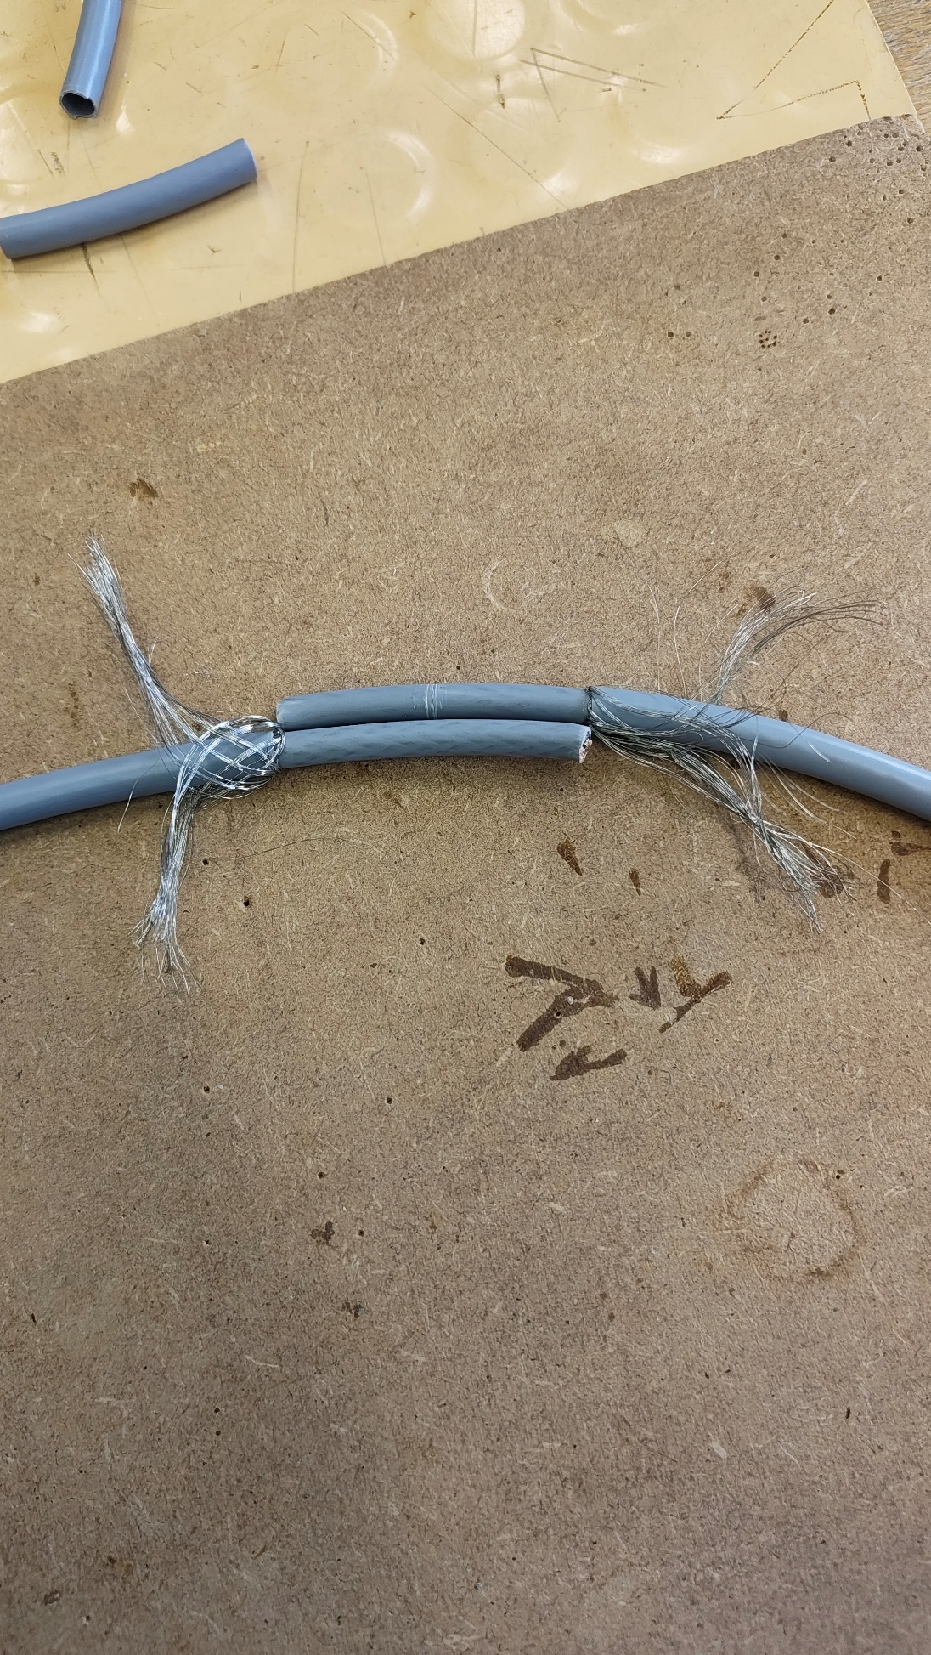

Removing the Inner Insulation Layer
Under the shielding, the inner protective layer is removed, exposing the four internal wires. At this stage, damaging the wires is unlikely, but care is still required.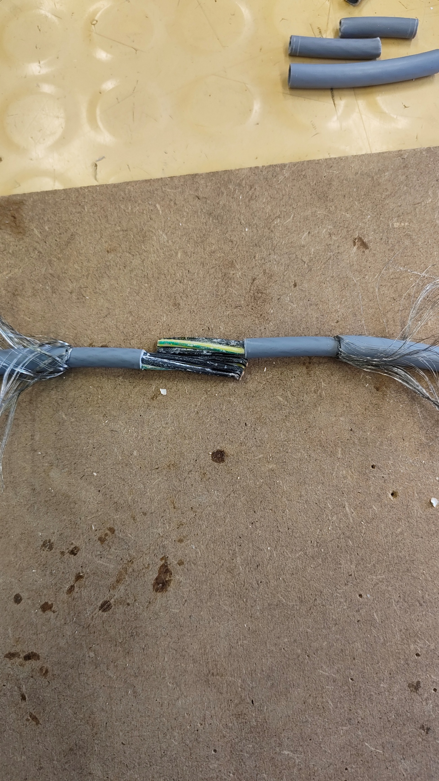

Preparing the Wires
The internal wires are aligned and cut at different lengths so that the solder joints are not located in the same position. This staggered method reduces the risk of short circuits.
A small amount of insulation is removed from each wire to expose the copper conductor.
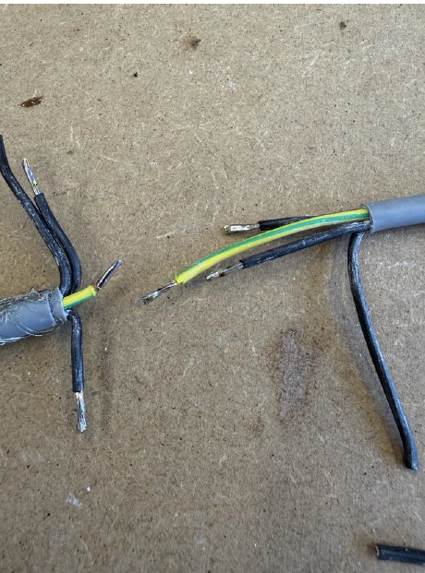

Soldering and Insulation
Before soldering, heat-shrink tubing is placed on the wires. After soldering, it will no longer be possible to add it.
The exposed copper ends are soaked with solder, then soldered together. Each joint is held steady until the solder solidifies.
After soldering, the heat-shrink tubing is moved over the joints and heated until it shrinks tightly, providing proper insulation.
The wires must remain straight, without angles or protruding parts.

Reconnecting the Shielding
The metallic braided shielding is twisted into a single strand and reconnected using the same soldering method.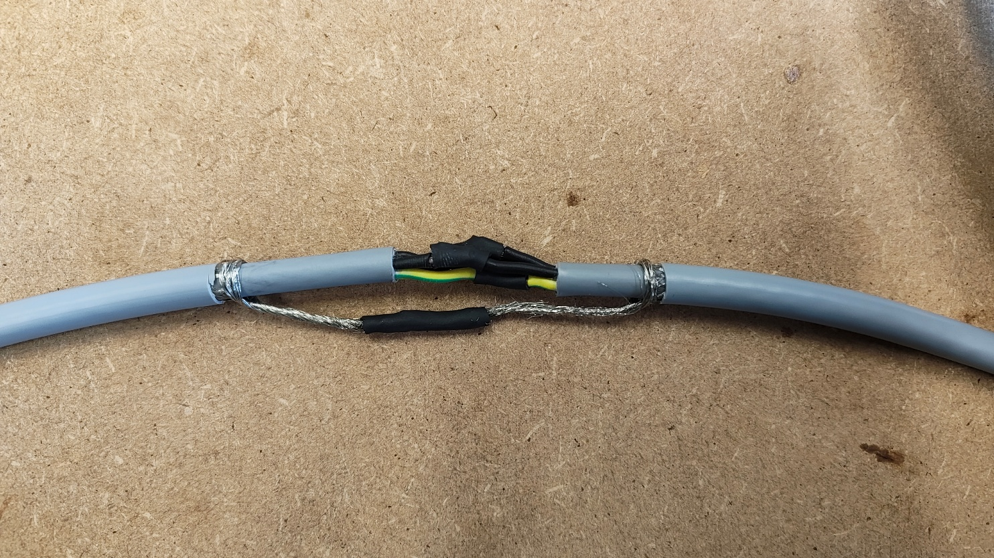

Conclusion
In conclusion, this work demonstrates how a multi-layer cable can be safely repaired. By carefully handling each layer, correctly soldering the internal wires, and restoring the metallic shielding, the cable regains its electrical functionality.

Website

Purpose of the site
This site is built to manage stations and their measurements. The main user capabilities are:
- register and log in;
- claim existing stations by serial number and edit them;
- view measurements (temperature, humidity, pressure, light intensity, air quality) per station and for a chosen time range;
- create collections (groups) of measurements from the visible table and manage your collections;
- manage friends and share collections (the UI for sharing exist; server-side requires further implementation).

User-facing pages (appearance, purpose, how to use)

Login
- Appearance: a centered card with Username and Password fields and a "Login" button.
- Purpose: authenticate existing users.
- How to use: enter username and password; on success the user is redirected to Account.php and a session is established.
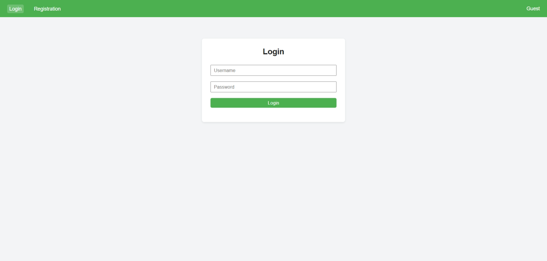

Registration
- Appearance: a registration card with fields Username, Full Name, Email, Password.
- Purpose: create a new user account.
- How to use: fill in required fields and press "Register". The app validates uniqueness of username and email and stores a hashed password.
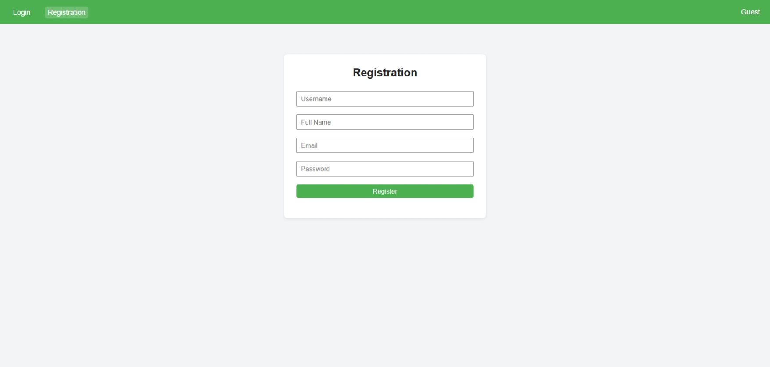

Account
- Appearance: a card showing Username, Full name, Email and an "Edit" button.
- Purpose: provide a quick overview of the currently logged-in user's profile.
- How to use: view your data and press "Edit" to open AccountEdit.php if you need to change profile details.
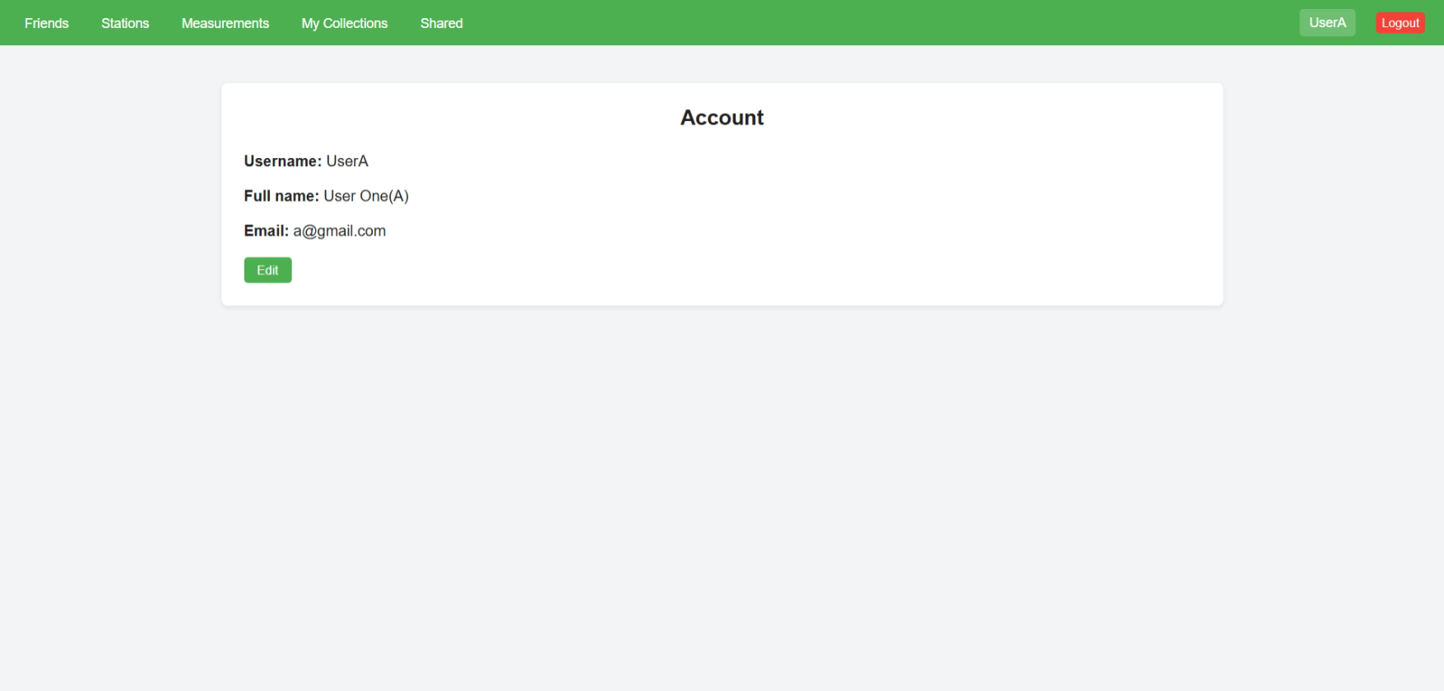

AccountEdit
- Appearance: a form with fields to edit Username, Full Name, Email, New Password and Current Password (required for confirmation).
- Purpose: update user profile and optionally change the password.
- How to use: enter updated values and your current password to confirm. On success the database and session values are updated.
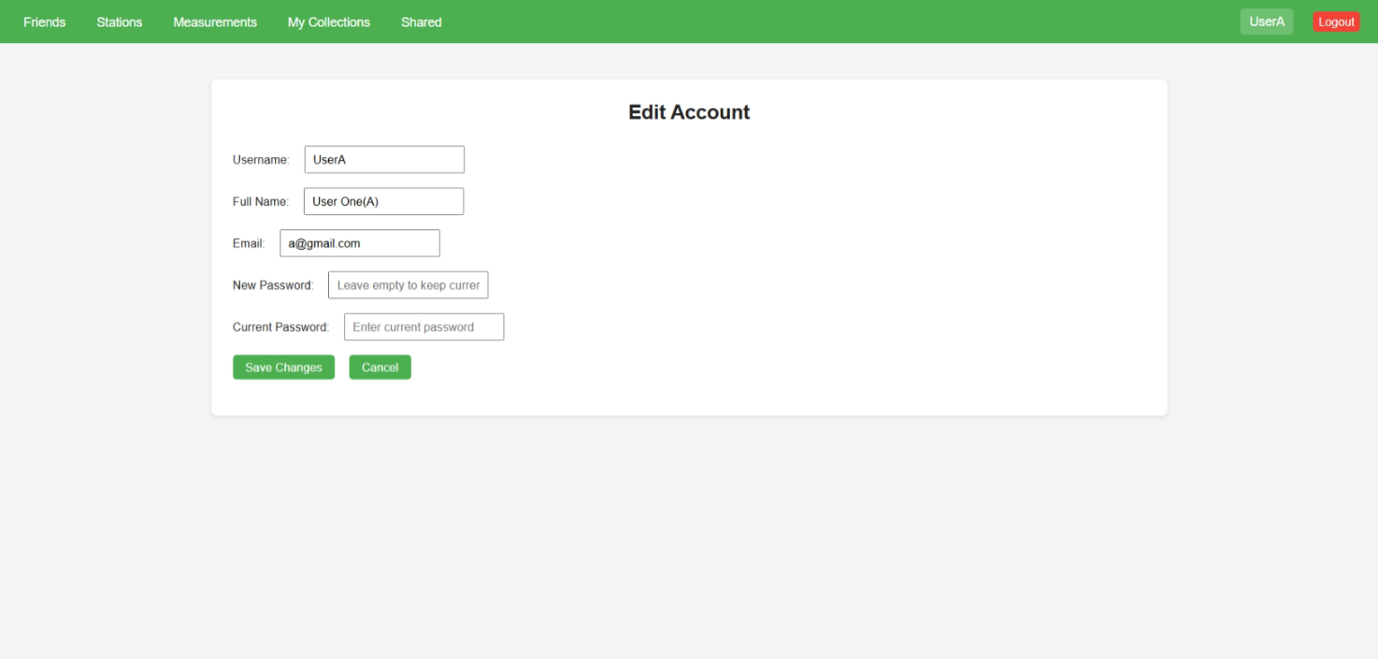

Stations
- Appearance: a form to claim a station (fields: Serial number, Station name, Description) and a list of the user's claimed stations with Edit/Delete buttons.
- Purpose: manage stations you own.
- How to use: to claim a station, enter its serial number and a display name, then press "Add station" — the station will be assigned to you only if it exists in the database and has no owner. Use Delete to release ownership.
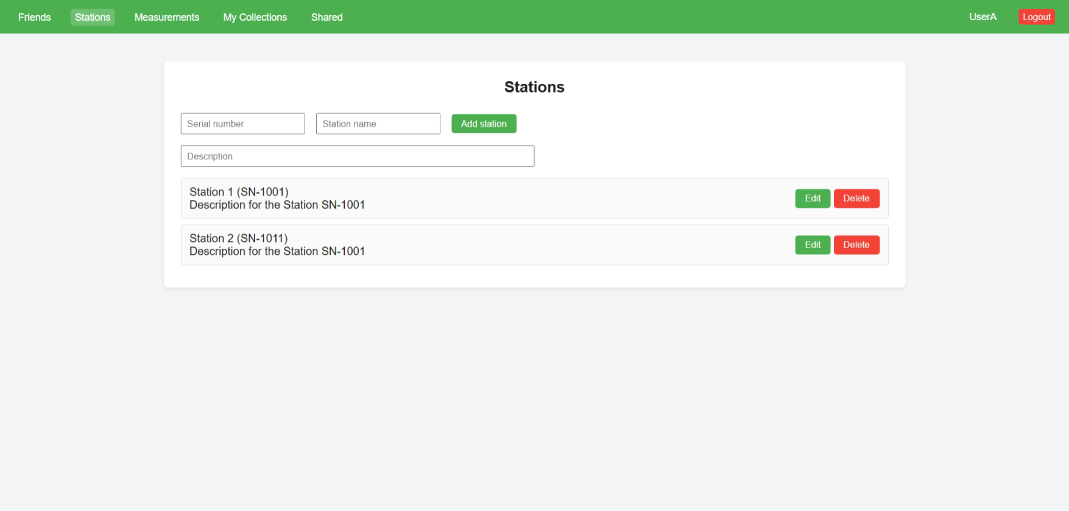

StationEdit
- Appearance: a form to edit Station name and Description; the serial number is shown read-only.
- Purpose: edit station metadata if you are the owner.
- How to use: open via Edit from Stations.php or by supplying sn in the URL, change fields and save.
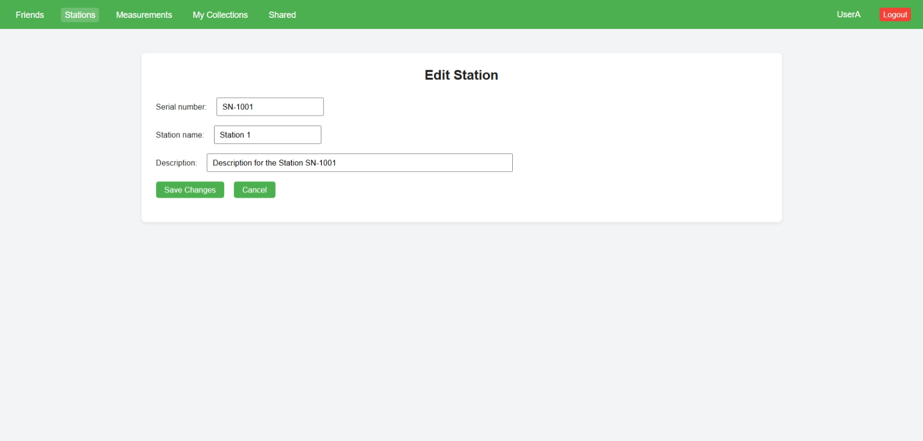

Measurements
- Appearance: a station selector (drop-down of your stations), Start and End datetime-local inputs, a "Show" button and a measurements table. A "Create collection" button opens a modal for naming a new collection.
- Purpose: view station measurements and create a collection from the currently visible measurements.
- How to use: select a station and optionally a date range, press "Show"; the table will populate with matching measurements. Click "Create collection" to open the modal, provide a name and optional description — the server will then create a collection containing all measurements that match the current filters.
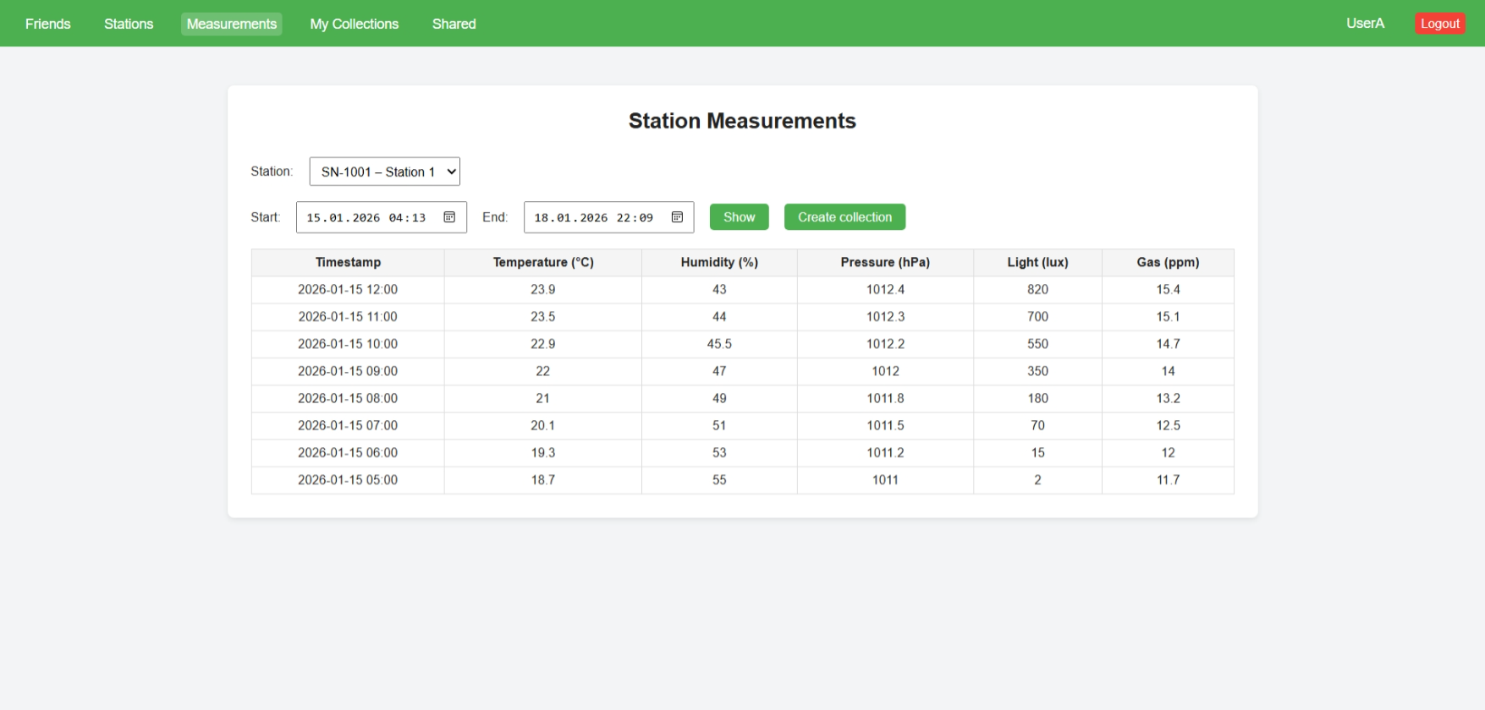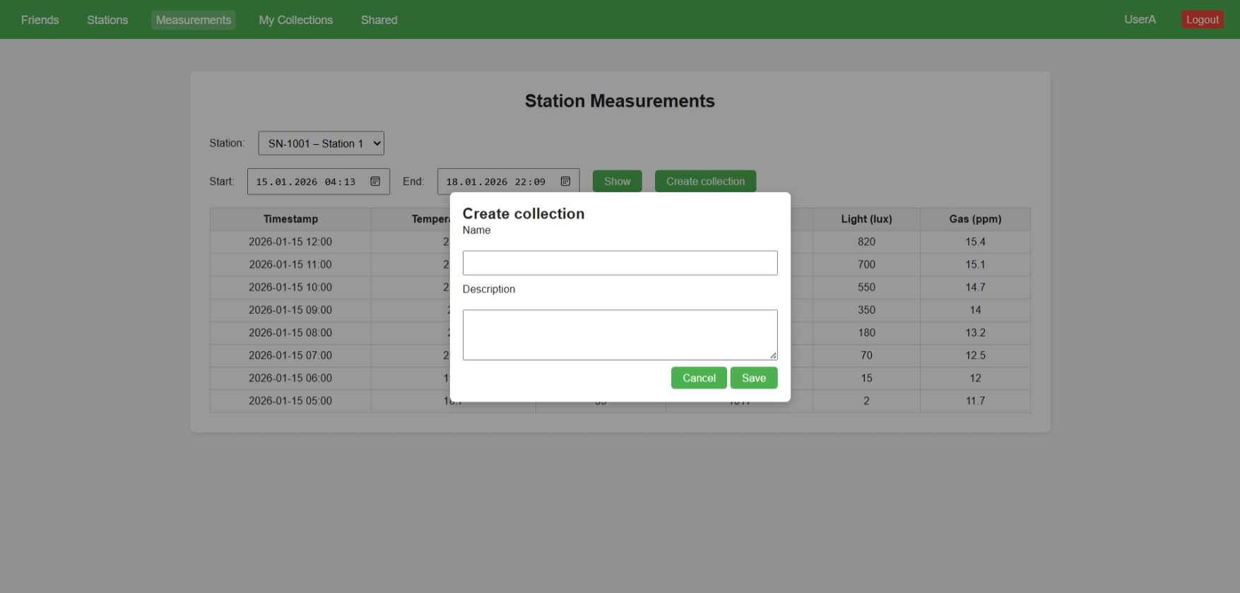

MyCollections
- Appearance: a list of your collections where each item includes name, description and buttons Open, Edit, Delete.
- Purpose: manage collections you created.
- How to use: open a collection to view it, edit metadata via Edit, or remove it with Delete (confirmation required).
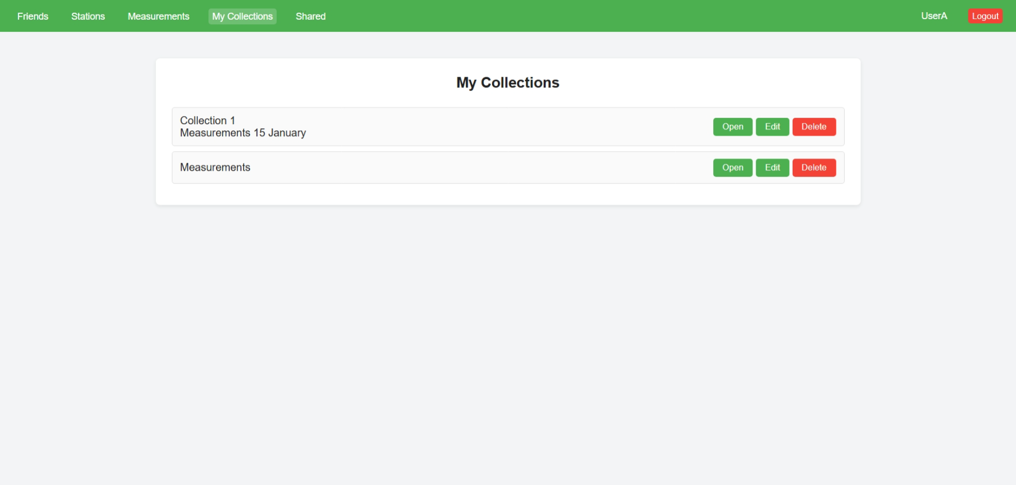

Collection
- Appearance: a card showing collection name, the collection owner, and a table listing the measurements that belong to the collection.
- Purpose: inspect the contents of a single collection.
- How to use: open the page using the Open button in MyCollections.php or via Collection.php?cid=<ID> to view measurement entries and collection metadata.
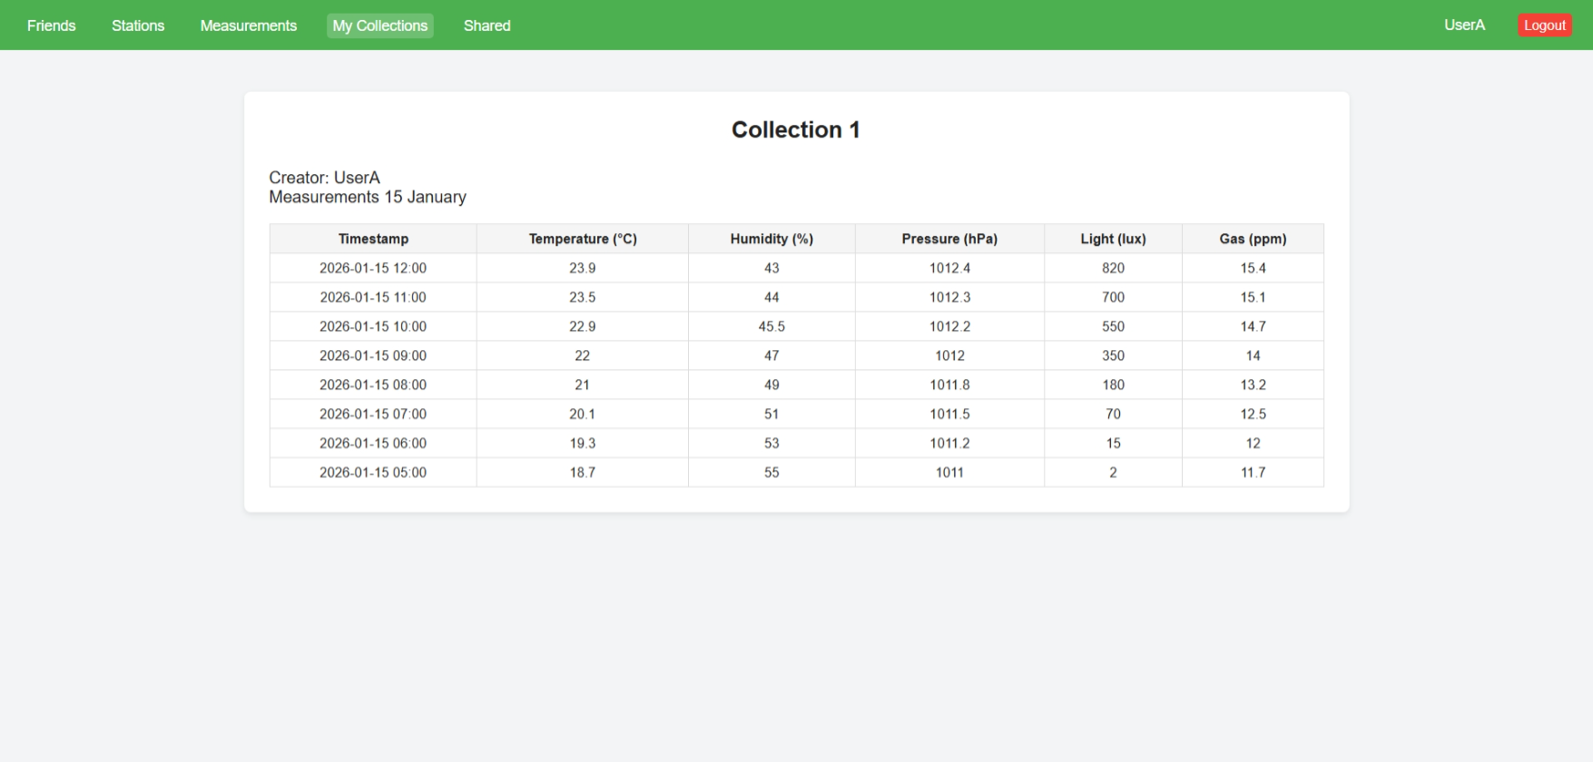

EditCollection
- Appearance: a form to edit collection name and description.
- Purpose: allow the collection owner to update collection metadata.
- How to use: open the page using the Edit button in MyCollections.php or via EditCollection.php?cid=<ID>, modify fields, and press "Save Changes".
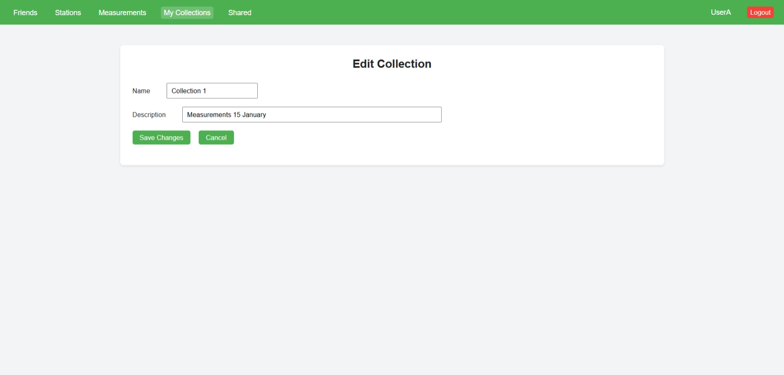

Friends
- Appearance: an input to enter a friend's username and an "Add friend" button; below is the list of friends with individual "Delete" buttons.
- Purpose: maintain a simple friend list to connect users.
- How to use: type a username and click "Add friend"; to remove a friend click "Delete" next to the desired username.
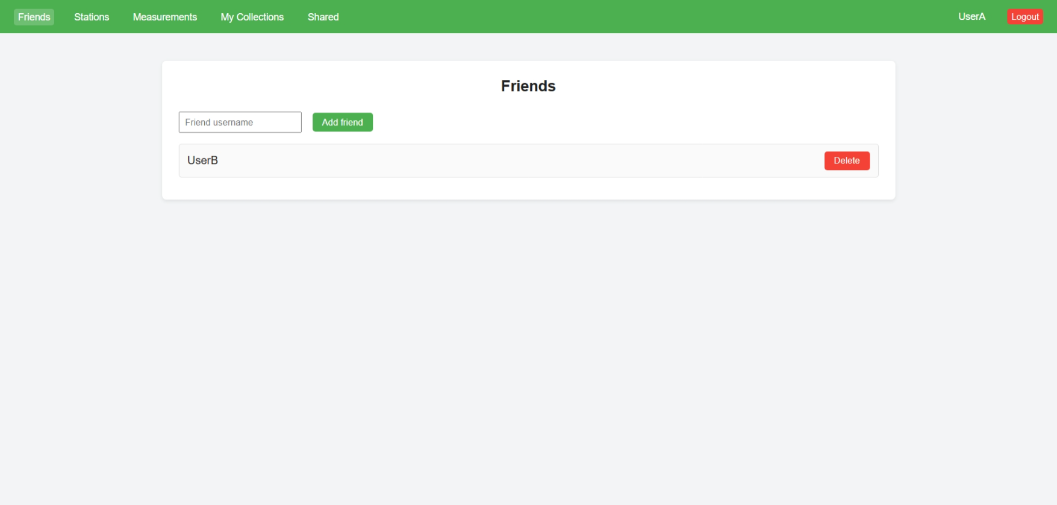

Shared
- Appearance: sections titled "My shared collections" and "Shared with me" with layout for collection cards and controls to show collection, add or remove shared users.
- Purpose: manage who has access to your collections and view collections shared with you. Current file provides only UI.
- How to use: use the add/remove controls to manage sharing, open a collection to view it.
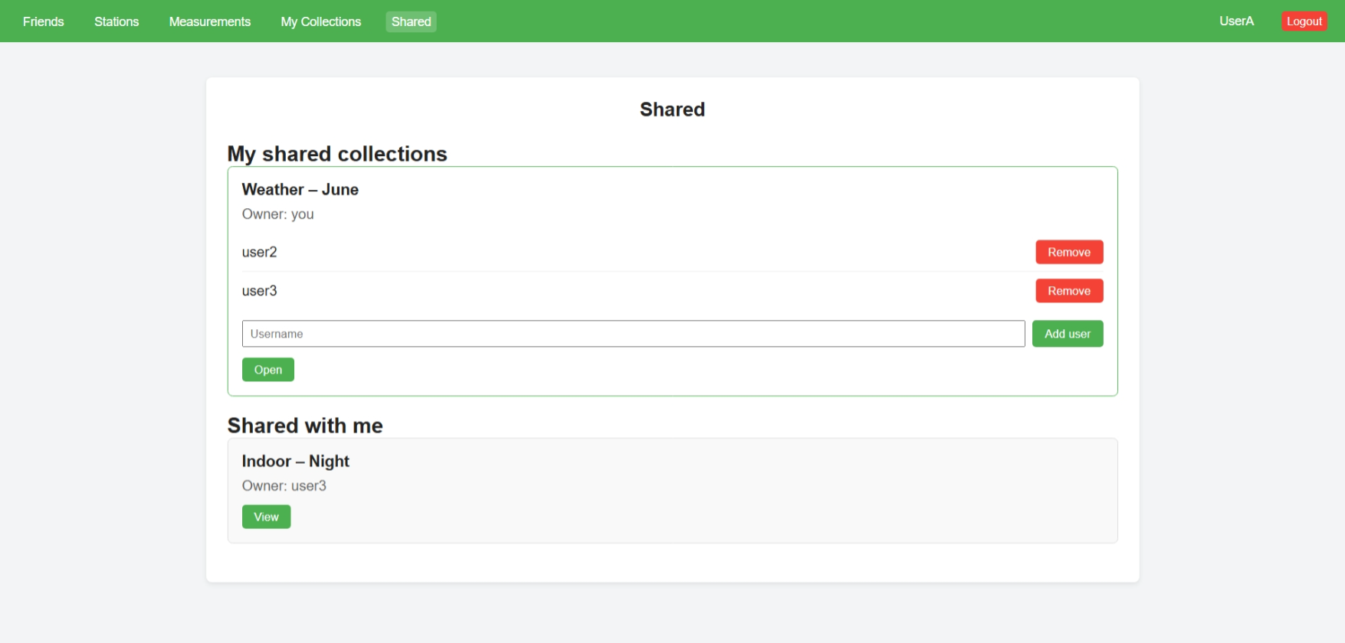

Logout
- Appearance: a simple confirmation card asking, "Are you sure you want to logout?" and a "Logout" button.
- Purpose: end the user's session.
- How to use: click "Logout" to destroy the session and return to the login page.
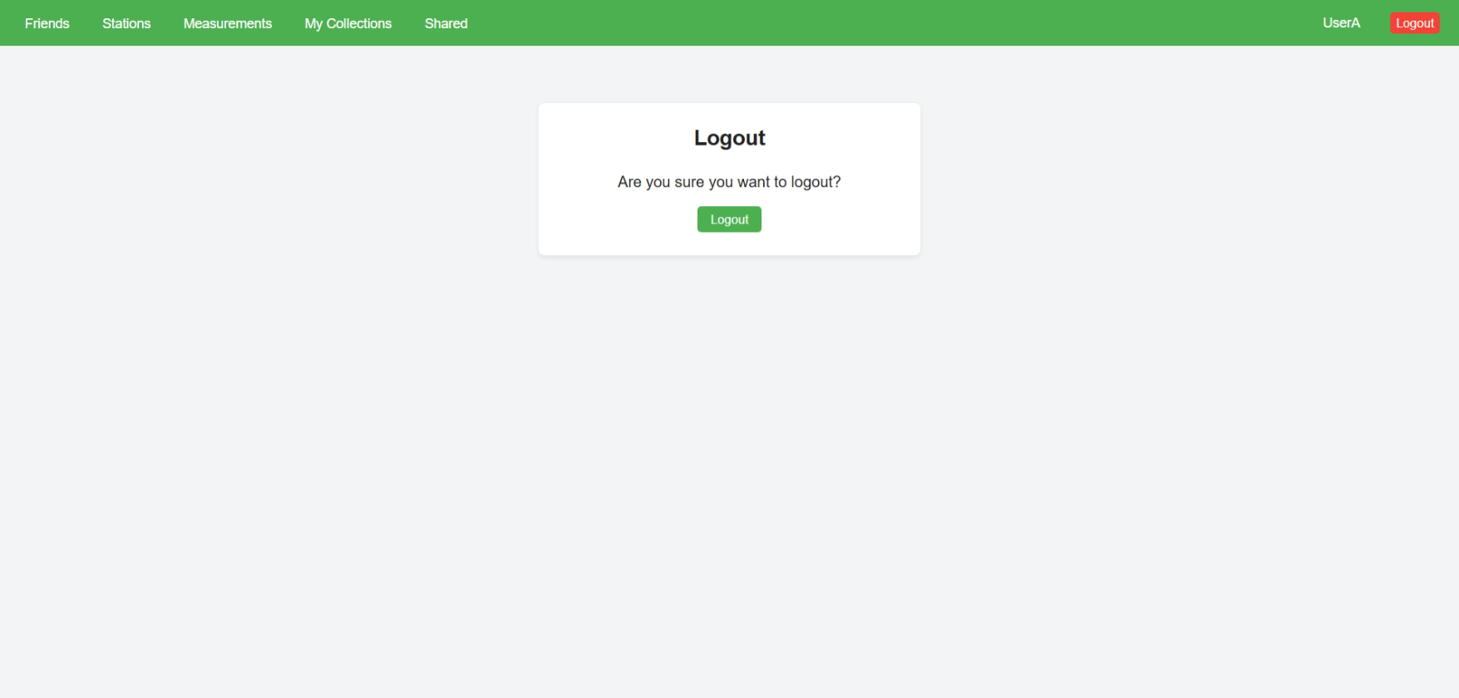

Sensor #1

List of materials
Component | Quantity
ADS1115 ADC module I2C | 1
MQ135 gas sensor | 1

Introduction
The aim of this assignment was to connect and test an MQ135 gas sensor to measure air quality.
The sensor is used together with an ADS1115 16-bit converter, which allows the Raspberry Pi to read analog values.
The ADS1115 module was installed earlier during Userstory A2 – PCB and is used in this assignment.
This task focuses on connecting the gas sensor and verifying that the full system works correctly.

ADS1115 Installation
During Userstory A2 – PCB, the ADS1115 converter module was added to the custom printed circuit board as an extra component for future sensor integration.
The ADS1115 module was placed in its correct position on the PCB and soldered carefully using a soldering iron and solder.
The solder joints were checked visually to ensure good electrical contact and mechanical stability.
This installation made it possible to connect analog sensors, such as the MQ135 gas sensor, in later assignments.


MQ135 Sensor Installation
For this assignment, no additional soldering was required.
The MQ135 gas sensor was inserted into its dedicated socket on the PCB.
The PCB is connected to the Raspberry Pi via GPIO pins and provides power and signal connections between the MQ135 sensor and the ADS1115 converter.
After installation, all components were visually inspected to make sure they were correctly placed and securely connected.
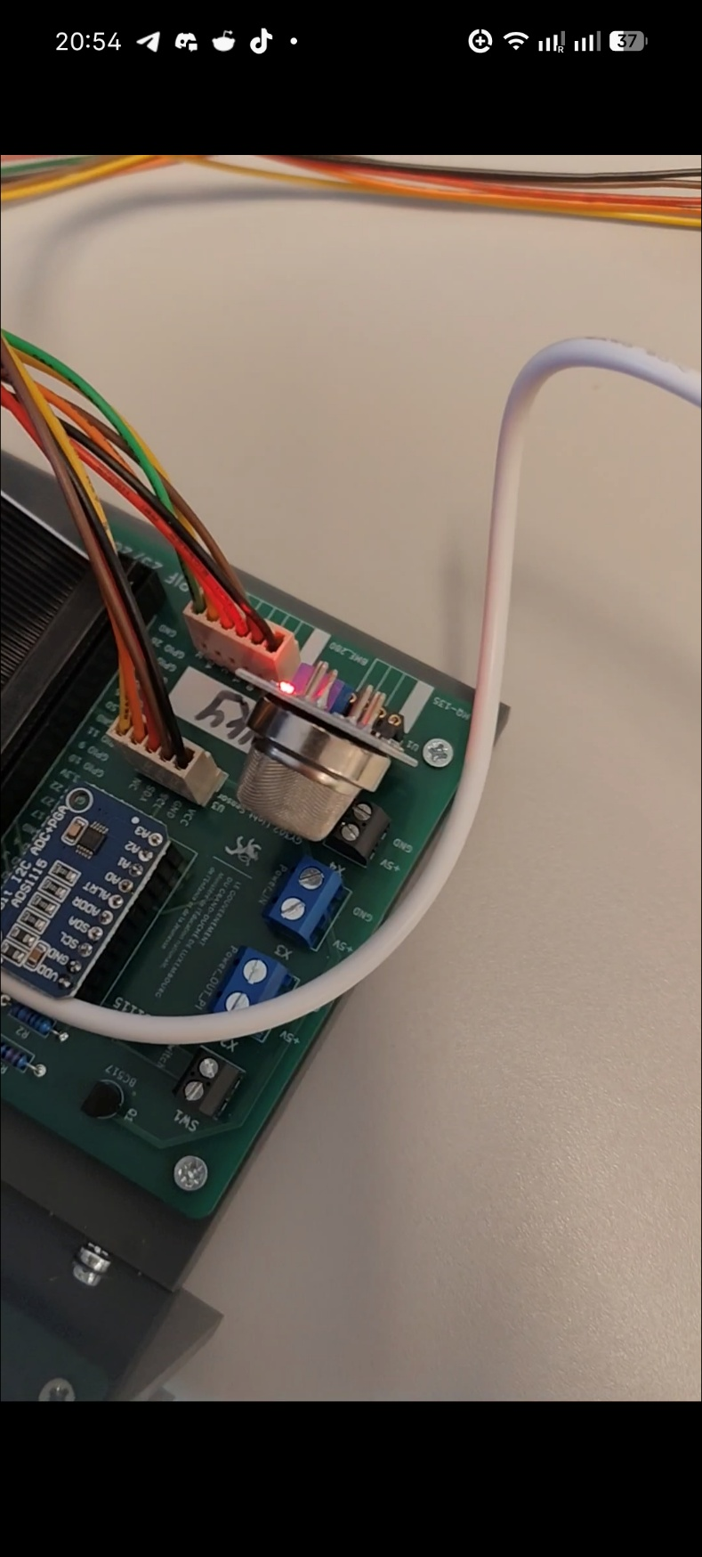

Sensor Testing
After powering on the Raspberry Pi, the I²C bus was scanned to check if the ADS1115 module was detected.
The following command was used:
sudo i2cdetect -y 1
The correct address appeared in the scan results, confirming that the converter was connected and working.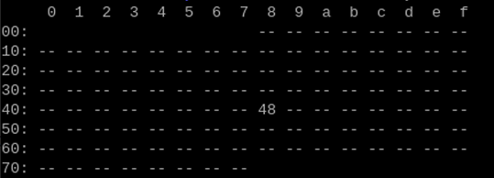
This address was then manually added to the Python script test-mq135.py, so the script could correctly communicate with the converter.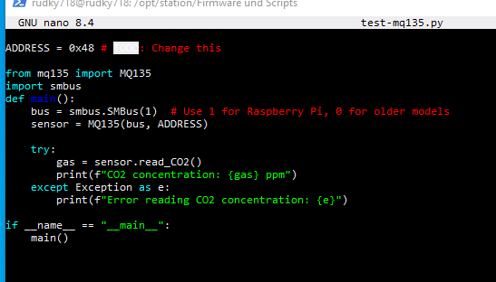

After updating the script, test-mq135.py was executed to read values from the MQ135 gas sensor. The script returned valid air quality data.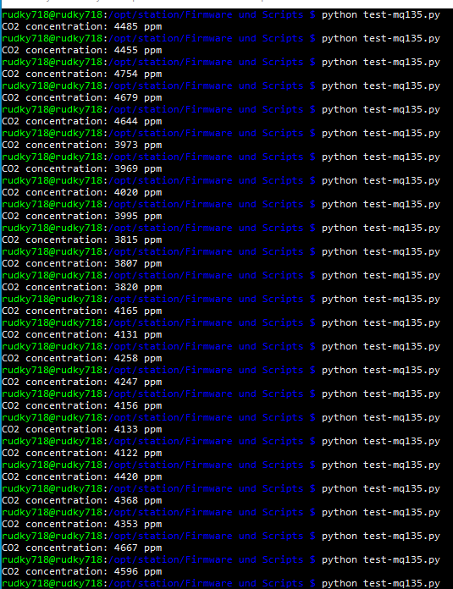

Conclusion
All connections and components were successfully tested and are working correctly.
The system can read data from the MQ135 gas sensor without errors.
However, the sensor still requires calibration, as the measured values do not fully match real air quality conditions.
The calibration can be done manually by adjusting the potentiometer on the sensor using a small screwdriver.

Sensor #2

List of materials
Component | Quantity
BME280 barometric (environmental) sensor | 1
BH1750 light sensor | 1
Plug-in cable | 2

Introduction
The aim of this assignment is to connect and test the BH1750 light sensor and the BME280 environmental sensor.
These sensors are used to measure brightness, temperature, and air pressure. To allow Raspberry Pi to read the sensor data, the ADS1115 converter is used.
The task focuses on installing the sensors and verifying that the system works correctly.

Sensors Installation
A plug-in cable was soldered to the BH1750 light sensor. Similar plug-in cable was also soldered to the BME280 environmental sensor.
During the installation of the BME280 module, two wires were not required. These unused wires were not connected to the sensor. To prevent short circuits, the open ends were covered with heat-shrink tubing. The tubing was placed over the wire ends and heated so that it shrank tightly around them. After heating, the ends were additionally pressed to fully close and protect the exposed wire.
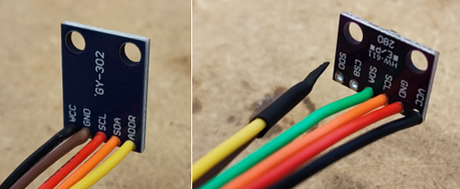
All solder joints were visually inspected to ensure clean and stable connections. After checking the soldering quality, the sensors were ready to be connected.
The cables were then simply plugged into the circuit board. No additional soldering was required at this step.


Sensors Testing
After powering on the Raspberry Pi, the I²C bus was scanned to check if the modules were detected.
The following command was used:
sudo i2cdetect -y 1
The correct addresses appeared in the scan results, confirming that the modules were working.
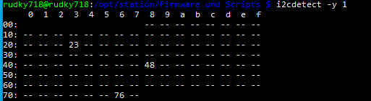
These addresses were then manually added to the Python scripts test-bme280.py and test-bh1750.py, so the script could correctly communicate with the converter.
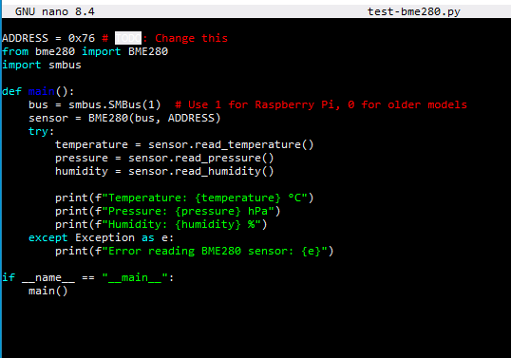
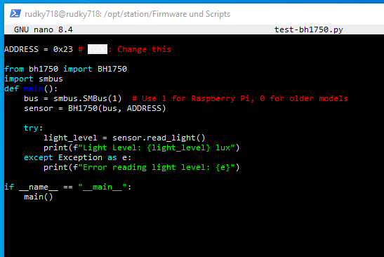

After updating the scripts, they were executed to read values from the BH1750 light sensor and the BME280 environmental sensor. The light sensor script returned valid data. However, when running the test script for the BME280 sensor, an error appeared.
The problem was caused by the fact that the module was not a BME280, but a BMP280. Because of this, the original script was not compatible.
To solve the issue, the script was modified and the required library was installed.
python3 -m pip install bmp280 --break-system-packages
Script:
from bmp280 import BMP280
from smbus2 import SMBus
import time

ADDRESS = 0x76

def main():
bus = SMBus(1)
sensor = BMP280(i2c_dev=bus, i2c_addr=ADDRESS)

while True:
temperature = sensor.get_temperature()
pressure = sensor.get_pressure()

print(f"Temperature: {temperature:.2f} °C")
print(f"Pressure: {pressure:.2f} hPa")
print("-" * 30)
time.sleep(2)

if __name__ == "__main__":
main()

After these changes, the sensor worked correctly and returned valid measurement values.

Conclusion
Both sensors were successfully soldered, connected, and tested. The unused wires were safely insulated to avoid short circuits.
After configuring the I²C addresses and running the test programs, the sensors provided valid measurement values.

Web Database Server

Introduction
In this task a web server and a database server were deployed on an Ubuntu Server using Docker containers.
The goal of the project was to create a working environment where a website can connect to a database and be accessed through the network.
The system was implemented using the following components:
- Apache with PHP for the web server
- MariaDB for the database server
- phpMyAdmin for database administration
- Docker and Docker Compose for container management
All services run in separate containers but communicate through a Docker bridge network.
The project also includes persistent database storage, Apache configuration, secure database configuration, and a test website to verify that the database connection works correctly.

Commands and Configuration

System Update
First the Ubuntu system was updated to make sure all packages were up to date
sudo apt update && sudo apt upgrade -y

Docker Installation
Docker and Docker Compose were installed together with required dependencies.
Install dependencies:
sudo apt install -y ca-certificates curl gnupg lsb-release
Add Docker GPG key:
sudo install -m 0755 -d /etc/apt/keyrings
curl -fsSL https://download.docker.com/linux/ubuntu/gpg | \
sudo gpg --dearmor -o /etc/apt/keyrings/docker.gpg
sudo chmod a+r /etc/apt/keyrings/docker.gpg
Add Docker repository:
echo \
"deb [arch=$(dpkg --print-architecture) \
signed-by=/etc/apt/keyrings/docker.gpg] \
https://download.docker.com/linux/ubuntu \
$(lsb_release -cs) stable" | \
sudo tee /etc/apt/sources.list.d/docker.list > /dev/null
Install Docker Engine and Docker Compose:
sudo apt update
sudo apt install -y docker-ce docker-ce-cli containerd.io \
docker-buildx-plugin docker-compose-plugin
Add the current user to the Docker group:
sudo usermod -aG docker $USER
newgrp docker

Verify Installation
docker --version
docker compose version
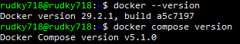

Project Structure Creation
A project directory structure was created to organize the containers and configuration files.
mkdir -p ~/pif-server/{webserver,database,phpmyadmin,mysql-data,www}
cd ~/pif-server

Docker Compose Configuration
Docker Compose was used to define the three containers required for the system:
- MariaDB database server
- Apache + PHP web server
- phpMyAdmin interface
Configuration
version: '3.8'
services:
database:
image: mariadb:11
container_name: pif-database
restart: unless-stopped
environment:
MYSQL_ROOT_PASSWORD: rootpassword
MYSQL_DATABASE: pif_db
MYSQL_USER: pif_user
MYSQL_PASSWORD: pif_password
volumes:
- ./mysql-data:/var/lib/mysql
networks:
- pif-network
webserver:
build: ./webserver
container_name: pif-webserver
restart: unless-stopped
ports:
- "80:80"
volumes:
- ./www:/var/www/html
networks:
- pif-network
phpmyadmin:
image: phpmyadmin:latest
container_name: pif-phpmyadmin
restart: unless-stopped
ports:
- "8080:80"
environment:
PMA_HOST: database
networks:
- pif-network
networks:
pif-network:
driver: bridge

Webserver Docker file
The web server container was built using the official PHP Apache image.
FROM php:8.2-apache
RUN docker-php-ext-install mysqli pdo pdo_mysql
RUN a2enmod rewrite
COPY apache-config/000-default.conf /etc/apache2/sites-available/000-default.conf

File Permissions
Website files were configured with correct ownership and permissions.
sudo chown -R www-data:www-data ~/pif-server/www
sudo chmod -R 755 ~/pif-server/www
sudo chmod -R 644 ~/pif-server/www/*.php
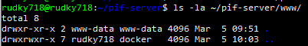

Start Docker Containers
The containers were started using Docker Compose.
docker compose up -d
Docker downloaded images, built the web server container and started the following services:
- pif-database
- pif-phpmyadmin
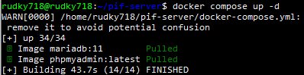

Secure MariaDB Installation
The MariaDB security script was executed inside the container.
docker exec -it pif-database bash
mysql_secure_installation
The script removed anonymous users, disabled remote root login, and removed the test database to secure the installation.
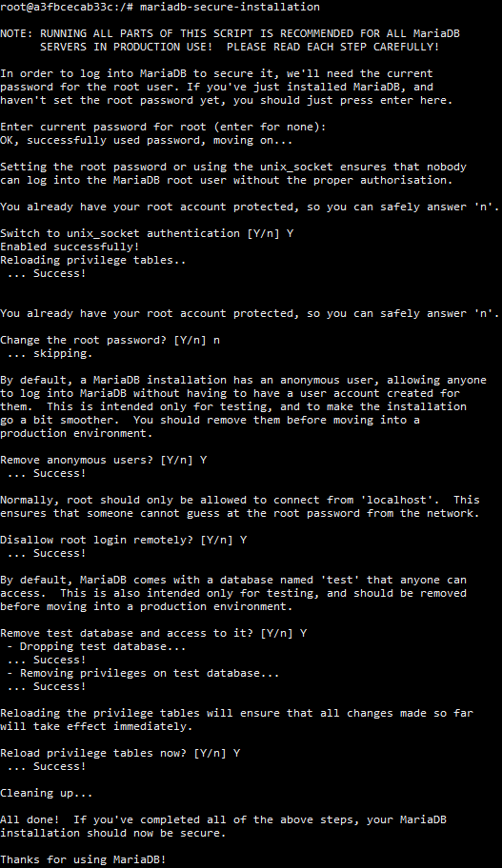

Database Configuration
A test database table and users were created.
SQL Commands
USE pif_db;
CREATE TABLE users (
username VARCHAR(50) PRIMARY KEY,
full_name VARCHAR(100),
email VARCHAR(100),
password_hash VARCHAR(200),
is_admin TINYINT(1)
);
INSERT INTO users VALUES
('admin','Admin User','admin@pif.lu',SHA2('admin123',256),1),
('user1','Test User One','user1@pif.lu',SHA2('user123',256),0);

Verification

Website and Database Test
To verify that the web server and database were working correctly, a test PHP page was created in the www directory.
This page connects to the MariaDB database using the credentials defined in the Docker Compose configuration.
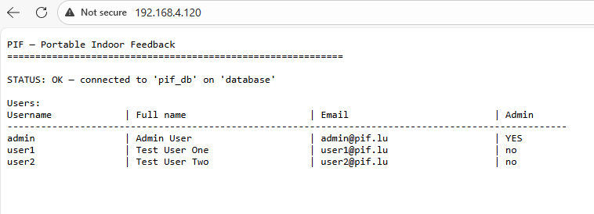

phpMyAdmin Test
To verify that the database could be accessed through phpMyAdmin, the following address was opened in the browser:
http://<server-ip>:8080
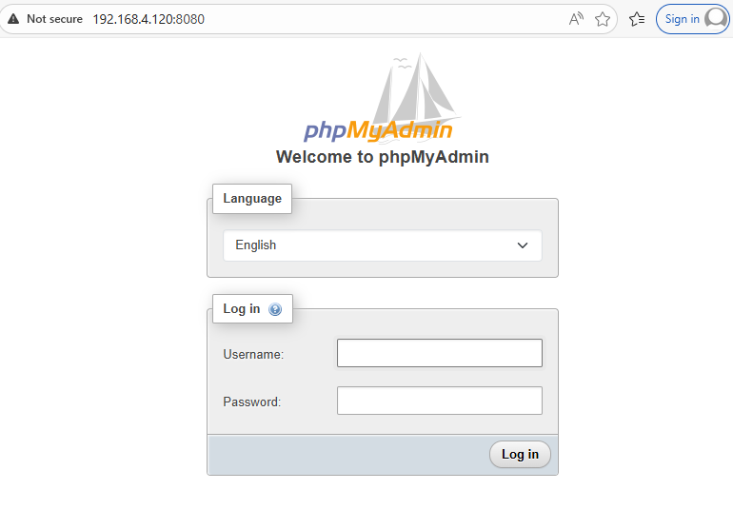

PHP Test
To verify that PHP was working correctly, a simple test file called test.php was created with the following code:
<?php
phpinfo();
When the file was opened in the browser (http://<server-ip>/test.php), the PHP information page was displayed.
This confirmed that PHP was correctly installed and working with the Apache web server.
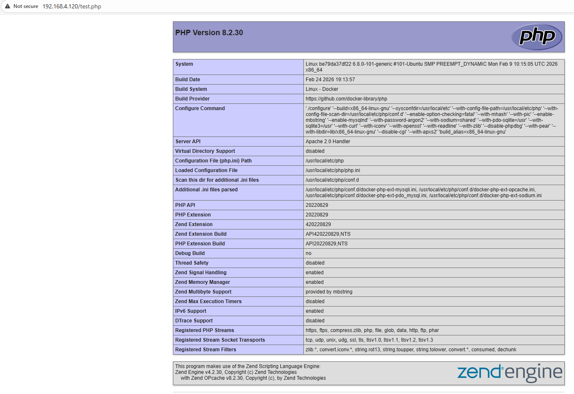

Making sure all packages up to date
sudo apt update && sudo apt upgrade -y
cd ~/pif-server
docker compose pull
docker compose up -d

Conclusion
The project successfully deployed a complete web and database environment using Docker.
Apache, PHP, MariaDB and phpMyAdmin were configured in separate containers connected through a Docker network.
The setup includes:
- Docker container orchestration using Docker Compose
- Apache web server with PHP support
- MariaDB database server with secure configuration
- phpMyAdmin for database administration
- Persistent database storage
- A test website to confirm successful communication between the web server and database server
This configuration provides a functional development environment that can be accessed through the network and easily maintained using Docker.

Assembly

List of materials
Component | Quantity
Wooden housing | 1
Power button | 1

Introduction
In this project, a wooden housing for a Raspberry Pi was assembled. The goal was to build a protective box using prepared wooden parts and to integrate additional hardware components such as a power button.
The project included assembling the wooden housing, preparing openings for hardware components, soldering the power button to the board, and installing two sensors inside the case.

Preparing the Opening for the Power Button
One of the tasks was to create an opening in the wooden panel for the power button. This button will later allow the Raspberry Pi to be turned on and off from outside the box.
First, the position of the hole was marked on the wooden panel. After that, a drill was used to create the opening. The hole was then checked to make sure the button fits correctly.
The edges of the hole were cleaned to make the opening smooth and ready for the button installation
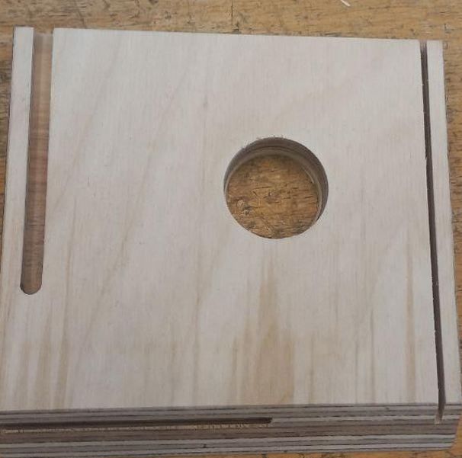

Assembling the Wooden Box
After preparing the panel, the wooden box was assembled.
All wooden panels were connected using dowel pins. These pins fit into pre-made holes in the panels and help align the structure correctly.
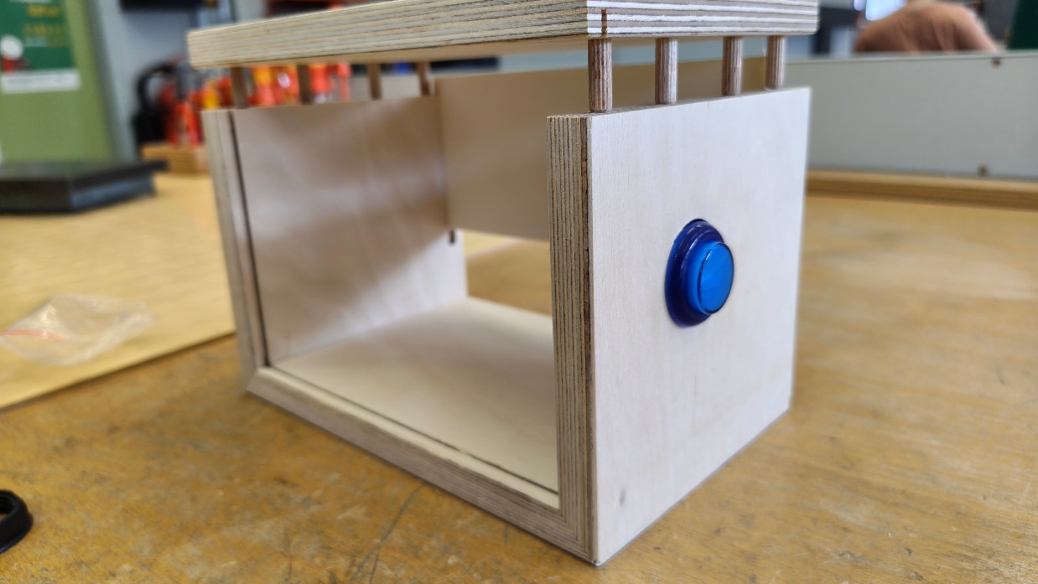

Mounting the Sensors
The next step was to install two sensors on the back panel of wooden housing. These sensors measure environmental data and send it to the Raspberry Pi.
Two openings were prepared in the wooden panel for the sensors. The sensors were inserted into these holes, so they remain stable and do not move.
The sensors were then secured using bolts and nuts so they stay firmly attached to the wooden panel.
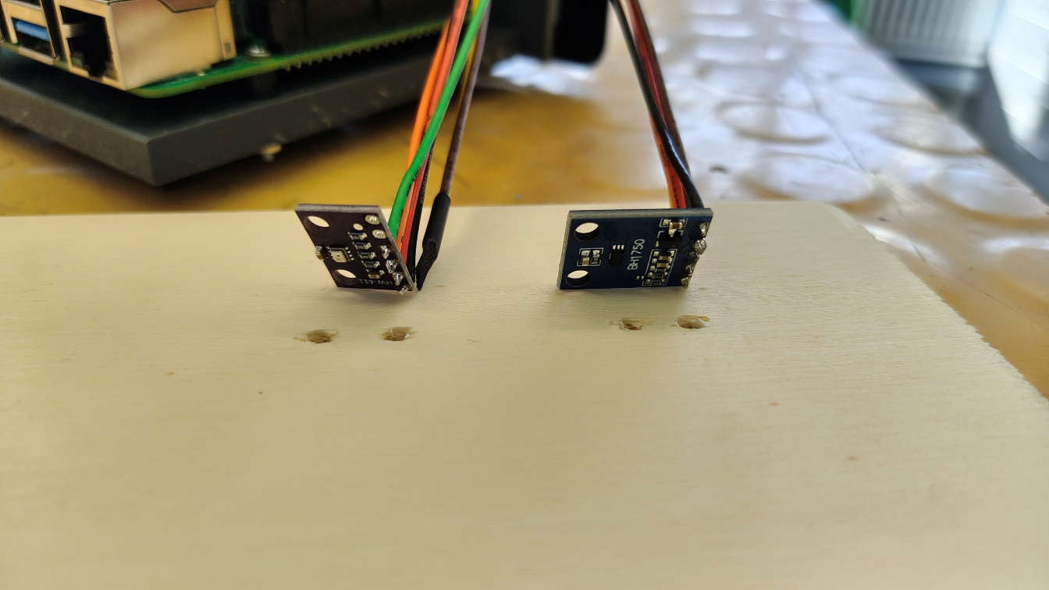

Connecting the Power Button
The power button needed to be connected to the Raspberry Pi.
First, the wires were soldered to the contacts of the button. A rubber insulating sleeve was placed over the connection to protect it and prevent short circuits.
The other ends of the wires were connected to the Raspberry Pi board using screw terminals. The wires were inserted into the connectors and fixed in place by tightening the screws with a screwdriver.
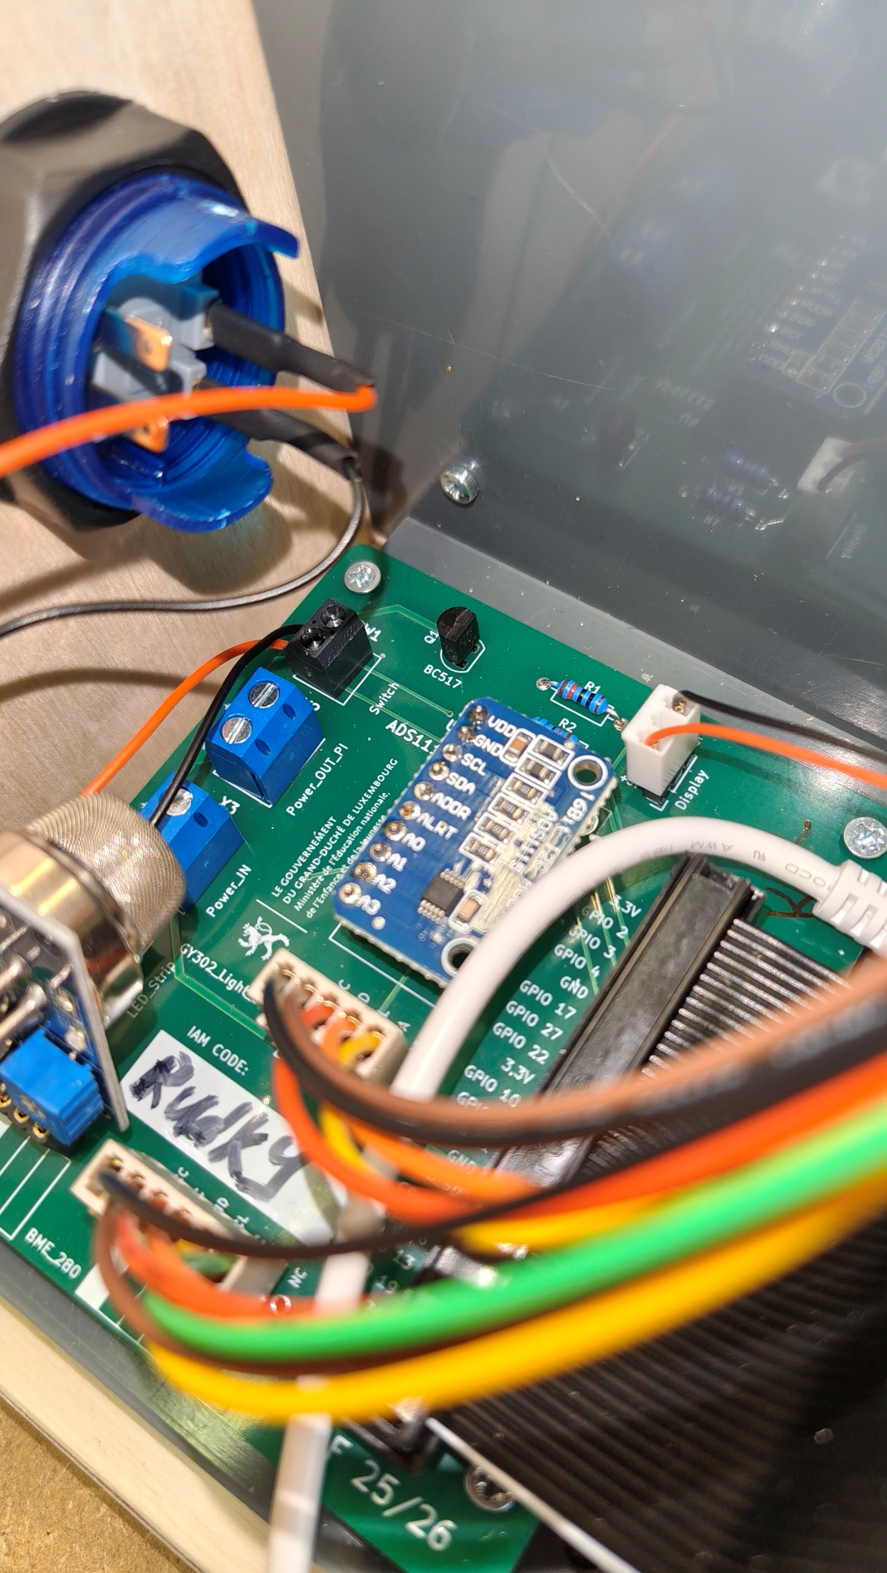

Conclusion
During this sprint, the wooden enclosure for the Raspberry Pi was successfully assembled.
The wooden panels were connected to form a stable structure, and two sensors were installed on the panel. The power button was wired and connected to the Raspberry Pi using screw terminals.
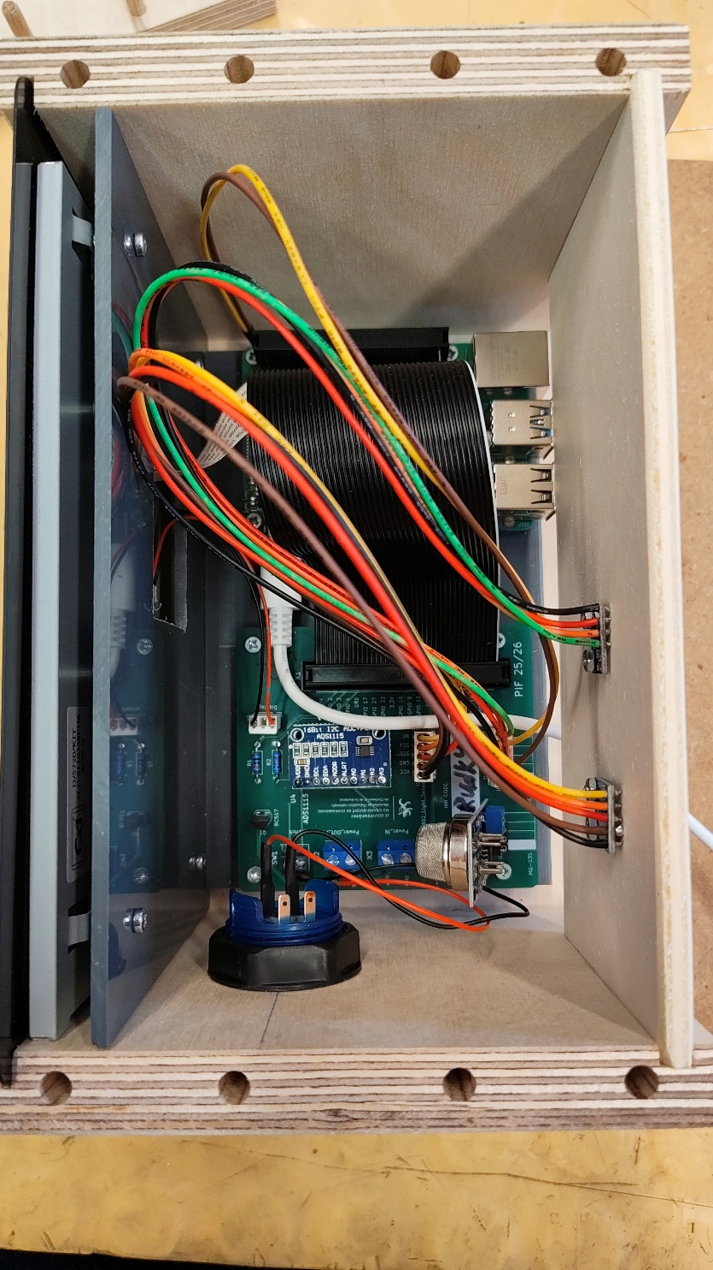

Data Transfer

Introduction
In this task, a data transfer system was implemented for the PIF project.
The goal of this task is to receive measurement data from a Raspberry Pi station and store it in a MariaDB database using a PHP script. The system is based on the infrastructure created in the previous sprint (L4), which includes Docker containers for:
- Apache + PHP (web server)
- MariaDB (database server)
- phpMyAdmin (database management)

PHP Script Creation
First, the PHP script for receiving data was created.
nano ~/pif-server/www/data_transfer.php
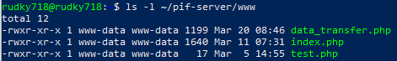
This script performs the following actions:
- Connects to the database using PDO
- Receives data via HTTP POST
- Validates input data
- Maps station_serial to stationID
- Inserts data into the Measurements table
The script is accessible via:
http://<server-ip>/data_transfer.php
This is important because the Raspberry Pi sends data to this address.

Database Preparation
The database must contain a table for storing measurements.
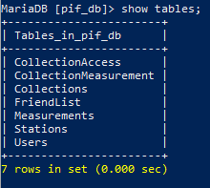
USE pif_db;
CREATE TABLE Measurements (
measurementID INT AUTO_INCREMENT PRIMARY KEY,
stationID INT NOT NULL,
timestamp DATETIME NOT NULL,
temperature FLOAT NOT NULL,
humidity FLOAT NOT NULL,
airPressure FLOAT NOT NULL,
lightIntensity FLOAT NOT NULL,
airQuality FLOAT NOT NULL,
FOREIGN KEY(stationID) REFERENCES Stations(stationID) ON DELETE CASCADE
);
stationID connects measurements to a station
Station must exist:
INSERT INTO Stations (serialNumber, name)
VALUES ('1', 'Test Station');
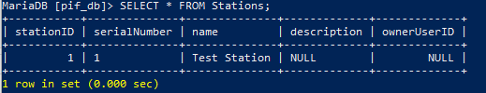
This is required because the PHP script maps station_serial to stationID.

Testing Data Transfer
To verify that the PHP script works, a manual request was sent using curl:
curl -X POST http://192.168.4.15/data_transfer.php \
-d "station_serial=1" \
-d "timestamp=2026-03-20 14:50:00" \
-d "temperature=25" \
-d "humidity=50" \
-d "pressure=1000" \
-d "light=10" \
-d "gas=500"
Expected result: OK
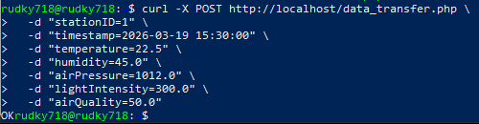
Result in Measurements table:
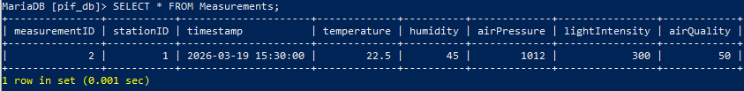
This confirms that the script successfully inserts data into the database.

Raspberry Pi Configuration
The Raspberry Pi uses a configuration file:
nano /opt/station/config.toml
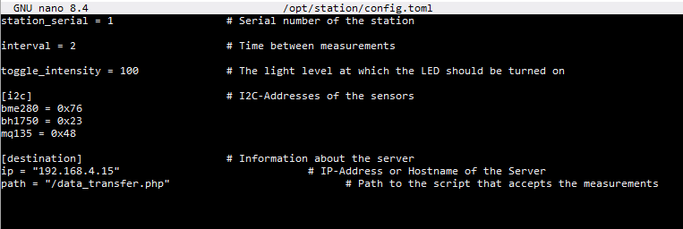
Important:
- ip is the server address
- path is the location of the PHP script
- station_serial is used to link the data in the database

Verification
To confirm that everything works:
Check database:
docker exec -it pif-database mariadb -u root -p pif_db \
-e "SELECT * FROM Measurements ORDER BY measurementID DESC LIMIT 5;"
Or check phpMyAdmin
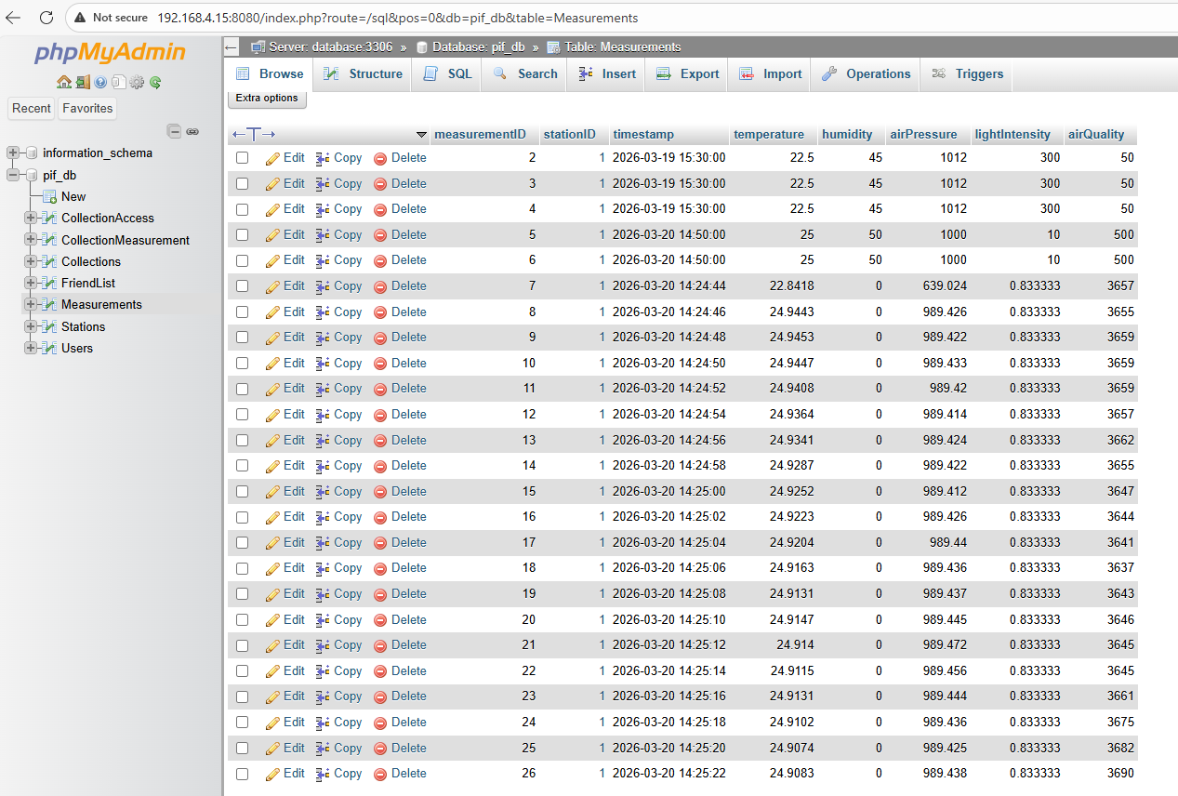
Data transfer is working correctly if new rows appear every few seconds

Manual Data Entry Form
To improve usability, a manual input form was added to the PHP script.
The form allows users to:
- Enter station serial number
- Enter measurement values
- Submit data to the database
The form is accessible:
http://<server_ip>/data_transfer.php
Explanation:
- step="0.01" allows decimal input (e.g. 25.17)
- Validation prevents incorrect data
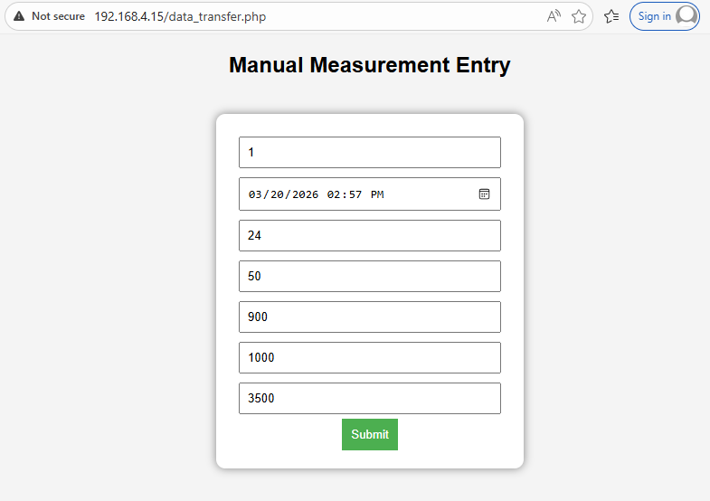
Result in Measurements table:
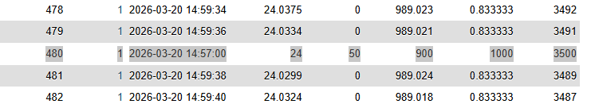

Conclusion
The data transfer system was successfully implemented. The Raspberry Pi sends measurement data via HTTP POST to the PHP script, which stores it in the MariaDB database.
All components (Docker, PHP, MariaDB, Raspberry Pi) work together as a complete system.

Code
<?php
$host = 'database';
$db = 'pif_db';
$user = 'pif_user';
$pass = 'pif_password';

try {
$pdo = new PDO("mysql:host=$host;dbname=$db;charset=utf8", $user, $pass);
$pdo->setAttribute(PDO::ATTR_ERRMODE, PDO::ERRMODE_EXCEPTION);
} catch (PDOException $e) {
die("DB ERROR: " . $e->getMessage());
}

$message = "";

// Handle POST (form or measure.py)
if ($_SERVER['REQUEST_METHOD'] === 'POST') {

$station_serial = $_POST['station_serial'] ?? null;
$timestamp = $_POST['timestamp'] ?? null;
$temperature = $_POST['temperature'] ?? null;
$humidity = $_POST['humidity'] ?? null;
$airPressure = $_POST['pressure'] ?? null;
$lightIntensity = $_POST['light'] ?? null;
$airQuality = $_POST['gas'] ?? null;

// Validation
if (!$station_serial || !$timestamp) {
$message = "ERROR: station_serial and timestamp required";
} elseif (!is_numeric($temperature) || !is_numeric($humidity)) {
$message = "ERROR: Invalid numeric values";
} else {

// Get stationID
$stmt = $pdo->prepare("SELECT stationID FROM Stations WHERE serialNumber=?");
$stmt->execute([$station_serial]);
$stationID = $stmt->fetchColumn();

if (!$stationID) {
$message = "ERROR: Unknown station serial";
} else {

// Insert
$stmt = $pdo->prepare("
INSERT INTO Measurements
(stationID, timestamp, temperature, humidity, airPressure, lightIntensity, airQuality)
VALUES (?, ?, ?, ?, ?, ?, ?)
");

$stmt->execute([
$stationID,
$timestamp,
$temperature,
$humidity,
$airPressure,
$lightIntensity,
$airQuality
]);

$message = "Data inserted successfully!";
}
}
}
?>

<!DOCTYPE html>
<html>
<head>
<title>Manual Data Entry</title>
<style>
body {
font-family: Arial;
background: #f4f4f4;
text-align: center;
}
form {
background: white;
padding: 20px;
margin: 40px auto;
width: 300px;
border-radius: 10px;
box-shadow: 0 0 10px gray;
}
input {
width: 90%;
padding: 8px;
margin: 5px;
}
button {
padding: 10px;
background: #4CAF50;
color: white;
border: none;
cursor: pointer;
}
.msg {
margin-top: 10px;
font-weight: bold;
}
</style>
</head>
<body>

<h2>Manual Measurement Entry</h2>

<form method="POST">
<input type="text" name="station_serial" placeholder="Station Serial" required><br>
<input type="datetime-local" name="timestamp" required><br>
<input type="number" step="0.01" name="temperature" placeholder="Temperature"><br>
<input type="number" step="0.01" name="humidity" placeholder="Humidity"><br>
<input type="number" step="0.01" name="pressure" placeholder="Pressure"><br>
<input type="number" step="0.01" name="light" placeholder="Light"><br>
<input type="number" step="0.01" name="gas" placeholder="Air Quality"><br>

<button type="submit">Submit</button>
</form>

<div class="msg"><?php echo $message; ?></div>

</body>
</html>

Lighting

List of materials
Component | Quantity
LED strip | 1
Cable | 1

Introduction
An opening was created on the side of the station near the screw terminal labeled LED_strip on the board.
This terminal is used to connect and fix wires by tightening screws. The hole allows the wire to pass from outside into the station and reach this terminal.

Preparing the Opening
An opening was created on the side of the station near the screw terminal on the board.
This terminal is used to connect and fix wires by tightening screws. The hole allows the wire to pass from outside into the station and reach the board.
The position of the hole was chosen carefully to ensure easy access to the terminal.
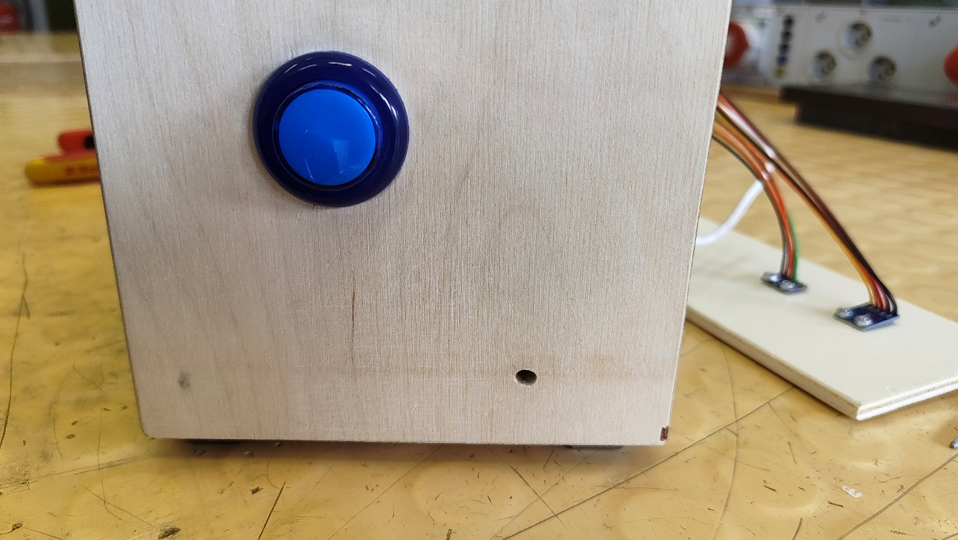

Preparing the LED Strip and Wires
The LED strip was cut to the required length. It is placed on the front side of the station.
After that, wires of the correct length were cut. The wires must be long enough to reach from the LED strip to the board inside the station.
The ends of the wires were stripped to prepare them for connection.
The wire enters from the side through the prepared opening and connects to the board inside.
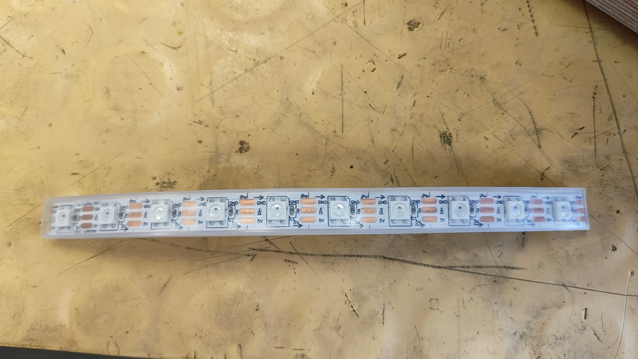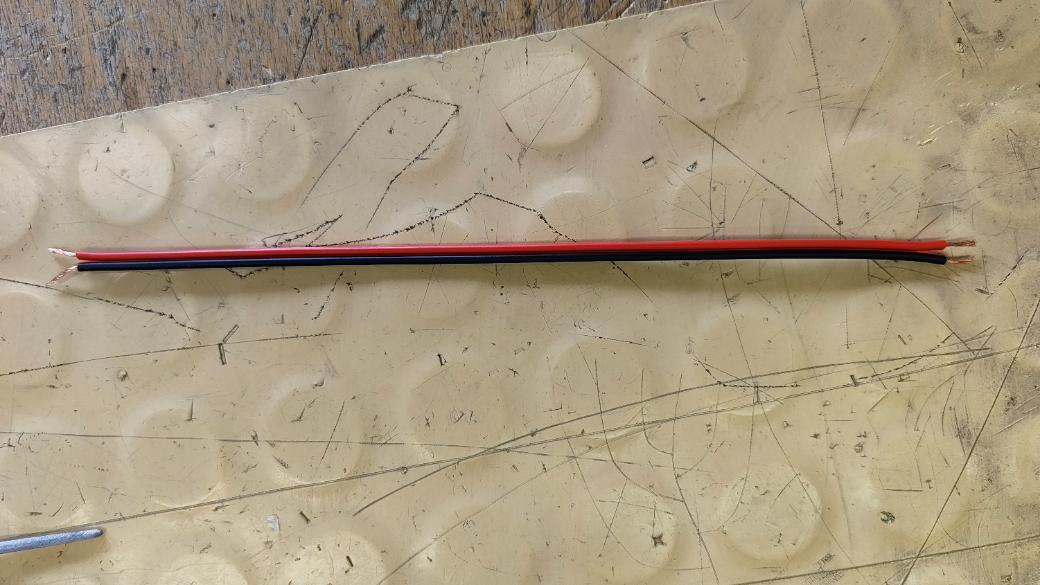

Connecting Components
One end of the wire was connected to the screw terminal on the board and fixed by tightening the screw.
The other end of the wire was soldered to the LED strip.
It is important that the same wire is connected to ground (GND) on both the Raspberry Pi board and the LED strip. Otherwise, the LED strip will not work.
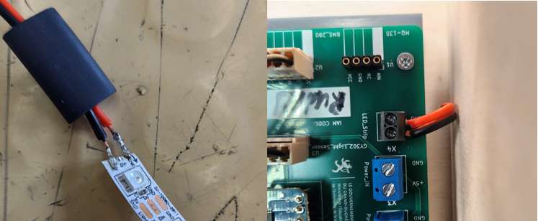

Insulation and Mounting
After soldering, heat shrink tubing was applied to the connections to ensure proper insulation and protection.
Finally, the LED strip was attached to the front side of the station using hot-melt adhesive.
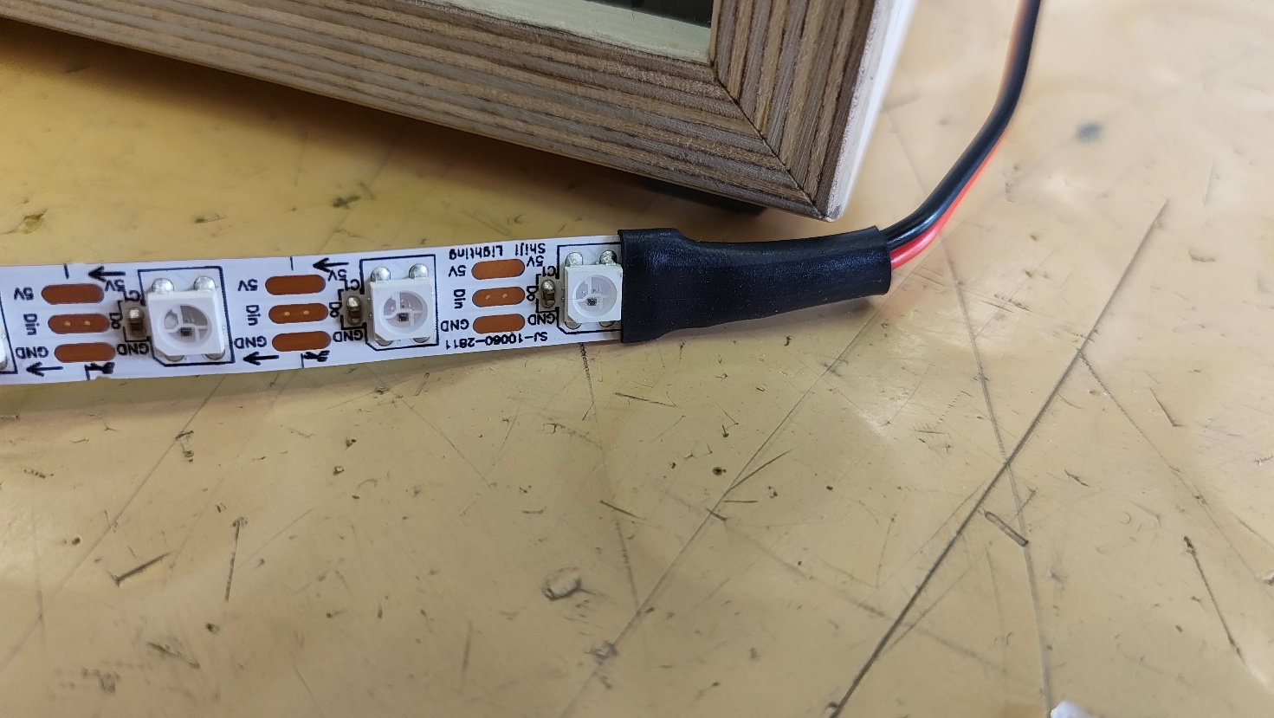

Conclusion
During this sprint, the LED strip was successfully installed and connected to the Raspberry Pi station. All physical steps, including cutting, wiring, soldering, and insulation, were completed.
The LED strip is designed to turn on when the brightness value is lower than 100. However, at the current stage, the LED strip does not work as expected.
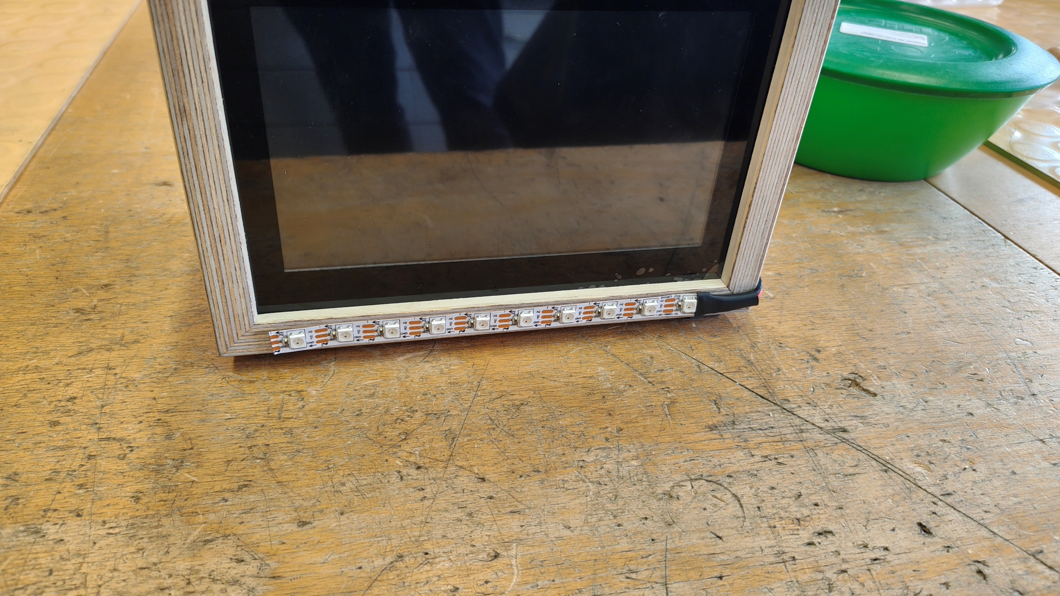

Backup Server

Introduction
The purpose of this assignment is to extend the existing system by implementing a backup server for the database server.
A separate backup server is used to automatically create database backups and store them safely. This improves reliability and ensures that data can be restored in case of system failure.

Web/DB Server Configuration

Allow External Access to MariaDB
The database runs inside Docker and is not accessible externally by default.
To allow the backup server to connect, port 3306 must be exposed.
Open the configuration file:
nano ~/pif-server/docker-compose.yml
Add port mapping to the database service:
ports:
- "3306:3306"
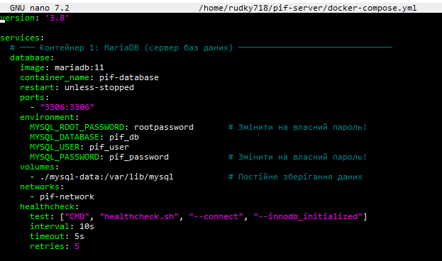
Restart containers:
cd ~/pif-server
docker compose down
docker compose up -d
Verify that the port is open:
docker compose ps
The output should contain:
0.0.0.0:3306->3306/tcp
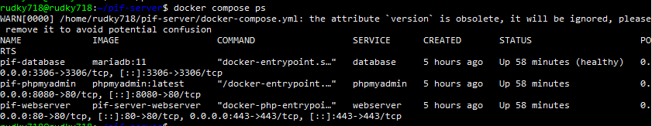

Create Backup User
A separate database user is created for backup operations.
This improves security by avoiding the use of the root account.
Connect to MariaDB:
docker exec -it pif-database mariadb -u root -p
Run SQL commands:
CREATE USER 'backup_user'@'%' IDENTIFIED BY 'backup_password';
GRANT SELECT, LOCK TABLES, SHOW VIEW, EVENT, TRIGGER
ON pif_db.*
TO 'backup_user'@'%';
FLUSH PRIVILEGES;
This user has only the required permissions for backup.
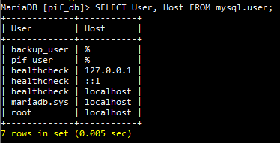

Backup Server Setup

System configuration
Update system packages:
sudo apt update && sudo apt upgrade -y
Set timezone:
sudo timedatectl set-timezone Europe/Luxembourg
timedatectl
Install client to connect to the remote database:
sudo apt install -y mariadb-client

Backup Directory
Create directory for storing backups:
sudo mkdir -p /backup/mysql
sudo chown rudky718:rudky718 /backup
sudo chmod 755 /backup
sudo chown rudky718:rudky718 /backup/mysql
sudo chmod 700 /backup/mysql
The /backup/mysql directory is restricted to the owner for security.

Backup Script
Create script file:
nano /backup/backup_mysql.sh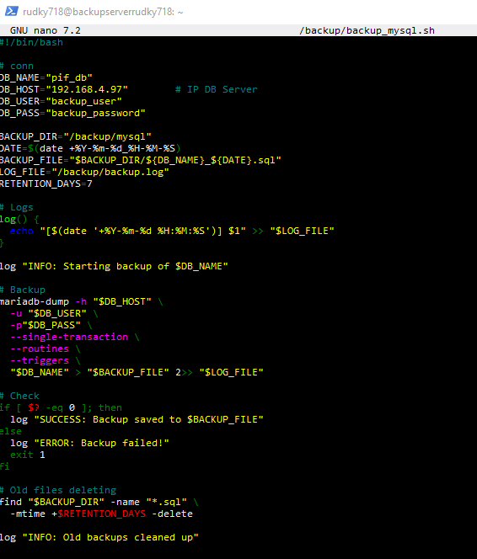

Make Script Executable and Test
chmod +x /backup/backup_mysql.sh
bash /backup/backup_mysql.sh
Verify backup:
ls -la /backup/mysql/
cat /backup/backup.log
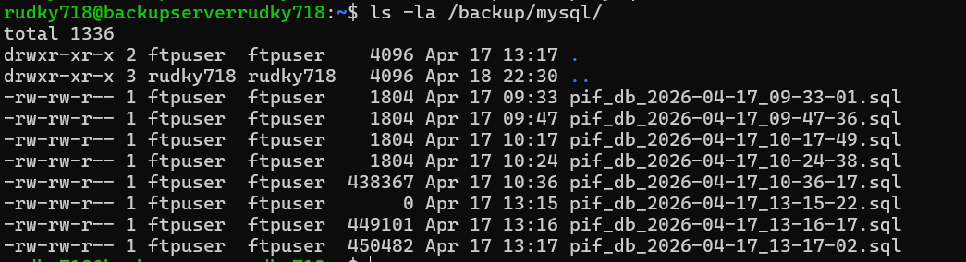

Cron Automation
Open crontab:
crontab -e
Add:
0 8 * * * /backup/backup_mysql.sh
Check cron jobs:
crontab -l
Check service:
sudo systemctl status cron
sudo systemctl enable cron
This runs the backup every day at 08:00.

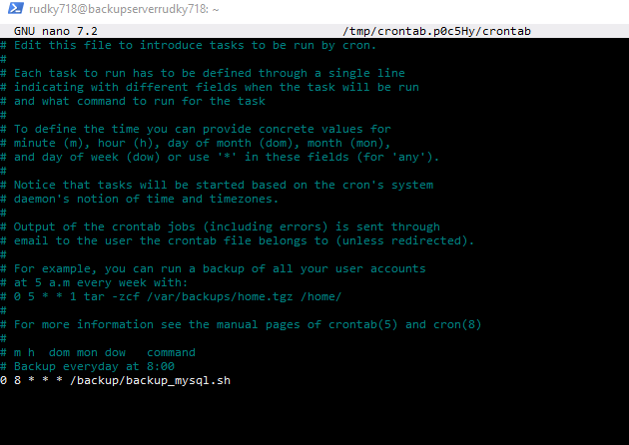

FTP
Install FTP Server
sudo apt install -y vsftpd
Configure FTP
Backup configuration file:
sudo cp /etc/vsftpd.conf /etc/vsftpd.conf.bak
Edit configuration:
sudo nano /etc/vsftpd.conf
Set parameters:
anonymous_enable=NO
local_enable=YES
write_enable=YES
chroot_local_user=YES
allow_writeable_chroot=YES
local_root=/backup/mysql
pasv_enable=YES
pasv_min_port=40000
pasv_max_port=50000

Create FTP User
sudo adduser ftpuser
Set permissions:
sudo chown -R ftpuser:ftpuser /backup/mysql
sudo chmod 755 /backup/mysql
Restart service:
sudo systemctl restart vsftpd
sudo systemctl enable vsftpd
sudo systemctl status vsftpd

Test FTP Connection
ftp 192.168.X.Y
Login:
Username: ftpuser
Password: ftpuser
Check files:
ls
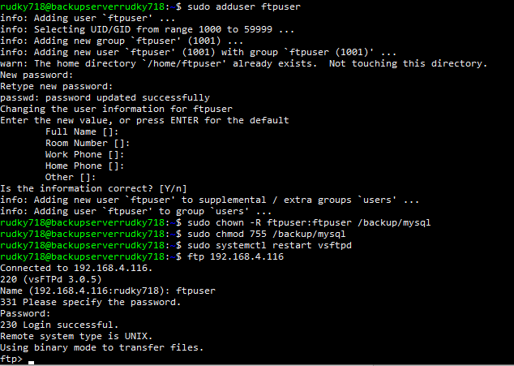

Conclusion
In this assignment, a backup system was successfully implemented using a separate server.
The database server was configured to allow external access, and a dedicated backup user was created with limited permissions.
The backup server automatically creates daily backups using a shell script and cron.
FTP access was configured to allow easy download of backup files from another machine.

Code
#!/bin/bash
# conn
DB_NAME="pif_db"
DB_HOST="192.168.4.97" # IP DB Server
DB_USER="backup_user"
DB_PASS="backup_password"
BACKUP_DIR="/backup/mysql"
DATE=$(date +%Y-%m-%d_%H-%M-%S)
BACKUP_FILE="$BACKUP_DIR/${DB_NAME}_${DATE}.sql"
LOG_FILE="/backup/backup.log"
RETENTION_DAYS=7
# Logs
log() {
echo "[$(date '+%Y-%m-%d %H:%M:%S')] $1" >> "$LOG_FILE"
}
log "INFO: Starting backup of $DB_NAME"
# Backup
mariadb-dump -h "$DB_HOST" \
-u "$DB_USER" \
-p"$DB_PASS" \
--single-transaction \
--routines \
--triggers \
"$DB_NAME" > "$BACKUP_FILE" 2>> "$LOG_FILE"
# Check
if [ $? -eq 0 ]; then
log "SUCCESS: Backup saved to $BACKUP_FILE"
else
log "ERROR: Backup failed!"
exit 1
fi

# Old files deleting
find "$BACKUP_DIR" -name "*.sql" \
-mtime +$RETENTION_DAYS -delete

log "INFO: Old backups cleaned up"

